ROYAL NORTHERN COLLEGE OF MUSIC

SHIFTING MODES OF RECEPTION:
CHOPIN’S PIANO SONATA IN B FLAT
MINOR, OPUS 35

DISSERTATION SUBMITTED IN PARTIAL FULFILMENT OF THE REQUIREMENTS OF THE MASTER OF MUSIC DEGREE IN PERFORMANCE
OF THE UNIVERSITY OF MANCHESTER

By

JONATHAN ISAAC OSHRY

This dissertation is my own work,
and has not previously been
submitted for assessment at this
or any other institution.

SEPTEMBER 1999

ACKNOWLEDGEMENTS

This thesis could never have been written without the help and support of various individuals. I would like to thank my supervisor, Dr Steven Jan, for his invaluable encouragement, input and guidance in the writing of this dissertation. My gratitude is also expressed to John Rink and Anatoly Leiken, both renowned exponents on the music of Chopin, for their advice as to the availability and importance of various source materials relating to Chopin’s piano sonatas.

I would also like to thank all those who were involved in the translation of the numerous source materials used in this dissertation: to Babara Gadja and Josef Alechowki, for unravelling the extremely complicated Polish articles (some of which had already been translated from the original Russian); to Katrien Matschke and Wendy Law for effecting the translation of the lengthy German articles; and to Naomi and Wendy Law for the translation of various French quotations.

Finally, and most importantly, I would like to thank my parents, Mr. and Mrs. Joshua Oshry, for their continual support of my musical career.

CONTENTS

1. INTRODUCTION 1
2. THE COMPOSITIONAL BACKGROUND 4
3. INITIAL RECEPTION (1841-1905) 9
4. LATE-NINETEENTH AND EARLY-TWENTIETH CENTURY RECEPTION (1890-1940) 15
5. LATER RECEPTION (1940-1996) 24
6. CHOPIN’S OPUS 35 IN HISTORICAL PERSPECTIVE 31
7. THE EARLY ANALYSES – LEICHTENTRITT AND RÉTI 38
8. FURTHER ANALYSES - WALKER AND OTHERS (1966-1990) 56
9. RECENT WRITINGS – SAMSON AND LEIKEN 67
10.THE FINALE 75
11.CONCLUSION 81
APPENDIX A: SCHUMANN’S CRITIQUE (1841) OF CHOPIN’S OPUS 35 83
aPPENDIX B: ANALYSIS OF THE FINALE OF CHOPIN’S PIANO SONATA IN B FLAT MINOR, OPUS 35 86
BIBLIOGRAPHY 91

LIST OF EXAMPLES

No. Description Page

1. Second subject of the first movement 22
2. Derivation of the second subject (top stave) from the first (bottom stave) 40
- Derivation of the accompaniment figure (top stave) from the first subject
(bottom stave) 40
4. Derivation of the third subject (top stave) from the first (bottom stave) 41
5. Rhythmic interconnection between themes 41
- Rhythmic link between the first subject of the first movement and the
main theme of the Funeral March 42
7. Modulation from the Trio to the Scherzo in the second movement 43
8. The link between the Scherzo and the Funeral March 44
- First movement: Link between the contours of the first subject and the
introductory motif 46
- Outline of bars 17-21 of the first subject of the first movement and their
relation to Motif I of the Grave 47
- Bass accompaniment of the first subject (bars 9-23) of the first movement
showing its relation to motifs I and II 47
- The relationship between the first and second subjects of the first
movement 48
13. Ornamented version of second subject (bars 57-59) 48
- The relationship between the first, second, and third subjects of the
first movement 49
- Similarity in outline between bars 229-241 of the first movement and
bars 1-8 of the Scherzo 50
16. Use of Motif Ib in the Scherzo 51
17. Use of Motif II in the Scherzo 51
- Similarity between the second subject of the first movement and the Trio
theme of the Scherzo 52
- Similarity between the first subject of the first movement and the main
theme of the Funeral March 52
No. Description Page

20. Similarity between the first subject of the first movement and the first
four bars of the Finale 53
21. Motif II as it appears in bars 5 and 7 in the Finale 53
22. Hints of a melodious second subject in the Finale 54
23. Derivation of Motif (b) from bars 1-4 of the first movement (a) 56
24. Derivation of the second subject 57
25. The use of Motif x (Example 24) in the second subject 57
26. Derivation of bar 99 from the first subject 58
27. The three-layered structure beginning bar 137 in the development 59
28. The use of the minor third in the Scherzo 60
29. Thematic integration of the Trio with the Scherzo 61
- Link between the Trio theme of the Scherzo and the Trio theme of the
Funeral March 61
- Link between the main subject of the Funeral March and the first subject
of the first movement 62
32. Use of the mediant degree in various subjects 62
33. The use of the introductory motif in the Finale 63
34. Link between the Scherzo and the first movement 73
35. Thematic link between the Scherzo and the first movement: the rising fifth 74

LIST OF TABLES

1. The derivation of subject material in the exposition of the first movement 71
2. Structural outline of the Finales of Chopin’s Sonatas opus 35 and opus 58 79

CHAPTER 1

INTRODUCTION

The second piano sonata, in B flat minor opus 35, of Frederic Chopin has long been the centre of controversy ever since Schumann’s negative comments thereon became widely known. This sonata is one of the most interesting, and perhaps most discussed, of all Chopin’s works, and has often been cited as an example of Chopin’s inability to cope with the large classical forms of the German tradition, especially by commentators writing around the turn of the twentieth century.

This view, however, slowly began to change. A few music theorists began to question Schumann’s opinion that, inter alia, Chopin was not comfortable in his use of sonata form. They objected to the flurry of negative responses to this work; one even claimed that it was because of only one critic’s proclamation that Chopin was not great enough to master sonata form, that scores of other critiques followed, repeating that same opinion ad nauseum. Those brave souls who opposed the norm were, it may be argued, eventually proved correct in their assumptions by various analyses that appeared in the twentieth century.

The purpose of this dissertation is twofold. Firstly, an overview of reception to this sonata will be conducted, quoting and presenting the opinions of various music critics, musicologists, pianists, and the like. Beginning with the famous comment by Schumann in 1841, right up to the present day, the writings of these people will be examined and critically evaluated. This will enable the identification of a receptive trend which, in turn, will be used to pinpoint the major turning point of change in reception and understanding of this sonata.

Secondly, this change in reception will need to be substantiated. This will be effected by study of the analyses of twentieth-century musicologists who attempt to disprove the unsubstantiated opinions of the earlier writers. These analyses range from the early classic writings of Hugo Leichtentritt to the more recent studies of Jim Samson and Anatoly Leiken. Here again, by examining these analyses in chronological order, it will become evident how each built upon those of the earlier analyses, thereby contributing to a better understanding of Chopin’s compositional style as it relates to the large classical forms.

The difficulty in obtaining newspaper articles and musical journals from the late-nineteenth and early-twentieth centuries necessitated the consultation of a limited number of sources, mainly books, that deal in part with reception of Chopin’s B Flat Minor Sonata Opus 35. Articles dealing specifically with this sonata may well appear in nineteenth-century Polish journals; these, however, have not been indexed, and would require more time and effort to uncover than has been available, never mind translating them. In addition, Polish writings of the nineteenth century contain only sporadic criticism of Chopin’s works. Similarly, English-language journals such as The Musical Times may contain articles dealing with Chopin’s opus 35; investigation in this area has likewise demonstrated a lack of indexation of source materials. Searching volumes of these journals for articles that may or may not exist has proved impractical given present constraints.

An examination of the comprehensive Chopin bibliography compiled by Kornel Michalowski (1985) has likewise proved to be of limited value. This book provides a list of source materials dating from 1849 to 1969 that have connections with Chopin and his works. The vast majority of articles listed under the subject of Chopin’s sonata opus 35 are in Polish; some of these have been consulted and translated. Moreover, many of the source materials are difficult to obtain. As far as reception dating from the period 1890 to 1940 is concerned, a chosen group of books dealing with opus 35 has been consulted, the selection of which was partly limited by availability. Here again, translation of a significant work in German was necessary.

This dissertation will begin with a discussion of the compositional background of Chopin’s second piano sonata, along with the early criticisms of Schumann and others. Thereafter, a sample of various writings dating from the 1840’s to the 1990’s will be presented, with a view to plotting a receptive trend line, as it were. An attempt at finding historical circumstances that may or may not have influenced Chopin’s approach to the sonata will then be followed by various analyses. Owing to the bewildered response, even in recent writings, of many musicians to the Finale, an attempt at disentangling this elusive movement, viewed by Schumann as a mockery, will be the subject of the final chapter.

CHAPTER 2

THE COMPOSITIONAL BACKGROUND

The handsome Louis XV bourgeois house Nohant in Berry provided the beautiful country setting where Chopin resided in the summer of 1839 with George Sand. Chopin’s liaison with Sand had begun in 1838, two years after their introduction by Franz Liszt. This was a time of contentment in Chopin’s life. His health was improving following illness in Majorca the preceding winter, he had the comfort of a devoted woman who loved him and understood his compositional frustrations and above all he was free to compose without the daily distractions of running a home. Compositions dating from this period were the G Major Nocturne opus 37, three of the four Mazurkas opus 41 and the F Sharp Major Impromptu opus 36. The other major achievement of this summer was the piano sonata in B flat minor opus 35.

The phase of creativity which began in Majorca with the second Ballade and the twenty-four preludes opus 28 continued in Marseilles with the C Sharp Minor Scherzo opus 39. The ideal working conditions at Nohant offered Chopin the opportunity to extend this productive phase; it is widely known that he composed little during the ensuing eighteen months in Paris. Sand noted his manner of working at the country residence:

His creation was spontaneous, miraculous. He found ideas without looking for them, without foreseeing them. They came to his piano, sudden, complete, sublime – or sang in his head while he was taking a walk, and he had to hurry and throw himself at the instrument to make himself hear them. But then began a labour more heartbreaking than I have ever seen… He shut himself up in his room for whole days, weeping, walking about, breaking his pens, repeating or altering a measure a hundred times, writing it down and erasing it as often, and starting over the next day with a scrupulous and desperate perseverance. He would spend six weeks on one page, only to return to it and write it just as he had on the first draft…

Sand is also known for the telling of the morbid visions that haunted Chopin while he sketched out his opus 35 piano sonata in Majorca.

Little could Chopin have known of the impending impact of this sonata. In fact, in a letter to his compatriot Julian Fontana dated Thursday August 1839, Chopin wrote:

Here I am writing a Sonata in B Flat minor, containing the march that you know. There is an allegro, then a Scherzo in E Flat minor, the march and a short finale, perhaps 3 of my pages; the left hand in unison with the right, gossiping after the march. I have a new nocturne…

The matter-of-fact manner in which Chopin writes about his new sonata is quite astonishing. The finale lasts around seventy seconds and concludes a work of more than twenty minutes’ duration. Jeremy Siepmann maintains that this movement, “which Chopin so casually dismisses as gossip, may well constitute the most enigmatic movement in the entire history of the sonata idea.” The sheer volume of critical commentary that this movement has evoked is substantial.

Chopin’s sonata opus 35 was first published in 1840 by Breitkopf & Härtel, and was sometimes referred to as Chopin’s “first sonata” as it was the first of all his sonatas to be published. It was also called the “Funeral March Sonata,” a title (unusually) approved by Chopin himself in 1847. The original “Marche funèbre” in B flat minor (1837) was not published until it was incorporated as the slow movement of the complete, four-movement sonata opus 35. It was, however, published separately in various editions following Chopin’s death, and performed in an orchestral version at Chopin’s funeral.

The other two piano sonatas of Chopin are the opus 4 in C minor and the opus 58 in B minor, which date from 1827 and 1844 respectively. Opus 4 was composed around the middle of a three-year course under Joseph Elsner at the Warsaw Conservatoire. To use the words of Jim Samson, it seems that his student efforts “…indicate all too clearly that in his early years at least this was not the air he breathed most naturally.” No reviews nor reports of nineteenth-century performances of this sonata have surfaced; even today the work is played no more than as a historical curiosity, or for the sake of providing a complete edition of Chopin’s piano music, as has been done by the pianist Vladimir Ashkenazy in recent years. Opus 58 originated during Chopin’s last happy, relatively untroubled summer at Nohant. It presented nothing like Opus 35’s march or short finale to arouse the sort of criticism directed at opus 35, although there were some reservations. Ironically, it will become evident that in fact the sonatas opus 35 and opus 58 are remarkably similar in their overall outline.

The second sonata consists of four movements, the first of which is in sonata form in the key of B flat minor, and is marked “Grave-Doppio movimento.” This is followed by a “Scherzo” in the key of E flat minor, in the middle of which is embedded a trio in G flat major. The third movement, the original funeral march in B flat minor (1837), is marked “Lento” and consists of two statements of the march between which is a trio in D flat major. The finale is marked “Presto” and is essentially a perpetuum mobile of four groups of quaver triplets per bar, in a kind of compressed sonata form.

According to Anatoly Leiken, the choice of a funeral march as the “centre of gravity” is no accident; Chopin was certainly attracted to this genre. Even though only one other of his compositions was designated as such (the Funeral March in C minor from 1829), he incorporated elements of the funeral march into several of his other works. Examples of this can be seen in the introduction to the F Minor Fantasy Opus 49, the C Minor Prelude from Opus 28 as well as various nocturnes such as Opus 48 No 1.

In most sonatas from the eighteenth and nineteenth centuries, the funeral march, if used instead of an adagio, would be employed as the second movement, with the scherzo as the third movement. In this sonata, however, those positions are reversed, as is the case with Beethoven’s piano sonata in A flat Major opus 26, one of Chopin’s favourite works. Leiken’s reasoning for this is that since the first movement of opus 26 is a relatively slow theme-and-variations, it seems only logical to insert the scherzo before the funeral march in order to introduce tempo contrasts between movements. Although the first movement of Chopin’s B flat Minor sonata is fast and basically in sonata form, this did not prevent Chopin from following Beethoven’s plan. In addition, Vladimir Protopopov highlights the fact that all of Chopin’s four-part cyclic works contain a scherzo or minuet as the second movement.

The single documented report of Chopin’s own performance of the B flat Minor Sonata around this time was when Moscheles visited Chopin in Paris in October 1839, shortly after the completion of the work. Moscheles was complimentary about Chopin’s work, proclaiming that only after hearing Chopin “…did I now for the first time understand his music, and all the raptures of the lady world become intelligible.”

It is interesting to note that no record exists of Clara Schumann playing the opus 35 sonata, in spite of the fact that she played both Chopin’s concertos and many other of his works. Chechlinska notes that Chopin’s sonatas in general were performed extremely rarely, both in Poland and throughout Europe. The first complete performance of the Sonata in B minor was reported only in 1866, more than twenty years after its completion. Chopin was known to have played the opus 35 sonata once in his final fourteen concerts beginning in Paris in 1839, that being in the Gentlemen’s Concert Hall, Manchester, on August 28 1848. In the decades following its publication, however, most renowned pianists included opus 35 in their concert repertoire, including Liszt, Tausig, Busoni, Anton Rubinstein, and Pachmann.

The basic compositional background of Chopin’s second piano sonata having been presented, the initial public reaction to this work will be examined in Chapter Three, with a view to providing a context for twentieth-century analyses which attempt to dispel negative comments about the work.

CHAPTER 3

INITIAL RECEPTION (1841-1905)

As noted in the introduction, Polish writings on music of the nineteenth century contain only sporadic criticism of Chopin’s works. Chechlinska observes that the earlier works of the larger forms (ballades, scherzi, and impromptus) were appreciated more than the later ones. She cites leading critics who regarded the G Minor Ballade as “the most magnificent,” while the F minor Ballade was described as “less happily conceived.” Today, few would dispute that the F minor Ballade is one of Chopin’s greatest works, and that it is the most beautiful of the set of four (a view supported by Alfred Cortot, an eminent interpreter of Chopin’s piano music).

From around Chopin’s time up until the last quarter of the nineteenth century, the public knew only a selection of Chopin’s works – those for piano and orchestra as well as works from the “second” period (i.e., the 1830s). Chechlinska notes that the later works, including the sonatas, and even earlier works whose musical technique deviated markedly from the norms of the time (e.g., the Prelude in A minor opus 28 No 2), were not readily understood. It was not until the end of the nineteenth century that they became a part of the standard repertoire, which is also around the time that reception of the second piano sonata, although initially negative, was beginning to change, as will be seen shortly.

The first major written criticism of Chopin’s sonata opus 35 was that of Robert Schumann, which appeared in 1841. Known, inter alia, for commenting on the works of his contemporaries, Schumann was unreserved in giving his opinion. His criticism of this sonata is legendary, and is referred to in almost any general discussion of this sonata in the literature. It became the catalyst for a chain reaction of countless other writings on the subject. Other critics often referred to Schumann when presenting their views on opus 35; many agreed with him, others questioned his opinions, while some even tried to read between the lines and offer different interpretations of his critique. Seeing that this review had such far-reaching consequences as far as the reception of the B flat Minor sonata is concerned, the complete review, translated from the original German, has been included in this dissertation, as Appendix A.

Reading Schumann’s critique, it can be concluded that, on a general level, he had the following reservations about opus 35:

- The binding together of four such different pieces under the title “sonata” is problematic, especially with respect to the fact that the last two movements have little to do with the first two. No organic or thematic unity seems to exist between the four movements. With reference to this comment, it might be added that the concept of “unity” is a very broad one, and, to use the words of Jim Samson, “a highly problematic notion in music.” There are various methods of uncovering the unity of a work; thematic unity between movements is but one of these methods.
- Chopin was not comfortable in his use of sonata form.
- The March does not belong to the rest of the work; rather, an adagio would have been more suitable.
- The finale is more mockery than music.
- The use of unusual harmonic devices, such as arbitrary and wild chord writing as well as excessive dissonance, makes the large-scale structure unclear.

At this point one could question Schumann’s astonishment at certain aspects of this work. Chopin was valued as an utterly original pianist and composer; the predominant view among critics in Poland for most of the nineteenth century was that Chopin’s music was of such a far-reaching originality that it showed no connections with the work of anyone else. Surely, then, if this “far-reaching” originality is what shapes Chopin’s music, why was this work singled out on account of a short finale and a supposed lack of unity? Was Chopin not adopting an original approach in the use of sonata form and the sonata cycle as a whole?

Moreover, another comment made by Schumann three years earlier seems to contradict his own view of Chopin’s opus 35 sonata. He wrote: “I no longer think about form [as a mold to be filled?] when I compose; [instead] I create it [intuitively?].” On this contradiction, Newman writes that “[y]et several times we shall find him calling attention to departures from what he regarded as standard sonata procedures, as in his review in 1841 of Chopin’s ‘Funeral March Sonata,’ Op. 35.” One should view this comment as being highly significant; yet, of all the sources consulted, only Newman seems to have mentioned it. Schumann disregards the fact that Chopin may have done exactly what Schumann permitted himself to do – create a form.

Two years later, J.W. Davison expressed a view quite contrary to that of Schumann:

Perhaps one of the most extraordinary of all the works of Chopin, both on account of its exceeding originality, and its strangely fantastic structure is the grand SONATA, in the sullen and moody key of B Flat Minor. This wild and gloomy rhapsody is precisely fitted for a certain class of enthusiasts, who would absolutely revel in its phantasmagorial kaleidoscope… [A lengthy poem follows, depicting the author’s image of the work.] Such are the impressions to which we are subject under the influence of this wonderful work – a very triumph of musical picturing – a conquest over what would seem it be unconquerable – viz. – the mingling of the physical and metaphysical in music – the sonata representing a dual picture - …the battle of the actual elements and the conflict of human passions – the first for the multitude, the last for the initiated.

This poetic description of the sonata was the usual manner of presenting a critical appreciation of a musical work at the time. Chechlinska notes that reviews of Chopin’s works during his time seldom mentioned his technical achievements; if included, they were discussed only in broad terms.

Of the various sources consulted, it is evident that the majority of critics disagree with Schumann’s comments. Those who do agree constitute a group originating mainly from the mid- to late-nineteenth and early-twentieth centuries. Prior to the 1940s, most writings concerning Chopin’s opus 35 were decidedly negative, although some critics questioned Schumann’s reasoning for his reservations about the work. One such writer was Henry T. Finck, who, in his 1889 work Chopin and Other Musical Essays, daringly proclaims:

I do not know whether he was a German or a French critic who first wrote that Chopin, although great in short pieces, was not great enough to master the sonata form. Once in print, this silly opinion was repeated parrot-like by scores of other critics. How silly it is may be inferred from the fact that such third-rate composerlings as Herz and Hummel were able to write sonatas of the most approved pattern – and that, in fact, any person with the least musical talent can learn in a few years to write sonatas that are absolutely correct as regards form. And yet we are asked to believe that Chopin, one of the most profound and original musical thinkers the world has ever seen, could not write a correct sonata! …Chopin not able to master the sonata form? The fact is, sonata form could not master him.

Finck may have a valid point in believing that many critics blindly agreed with each other (and therefore with Schumann) without looking at the work objectively and drawing their own conclusions. He adds that Chopin was not the first who tried to get away from the sonata, citing the numerous poetic licences evident in Beethoven’s sonatas as an example. This negative attitude, however, changed drastically in the twentieth century. Since the mid-1940’s, the vast majority of writings on the subject of opus 35 are positive and oppose many aspects of Schumann’s critique. Evidence of this is found in several analyses undertaken, the most important of which will be examined in due course. This highlights the fact that the improvement in standing of Chopin’s opus 35 is as a result of a more analytical approach to the work.

Another writer who opposed the negative appraisal of opus 35 at the turn of the century was G.C. Ashton Jonson. He believed that the partial quotation of Schumann’s critique resulted in a misunderstanding of Schumann’s view of the work.
He maintains that “Schumann never meant to say that these four wildest children were not related and were only bound together fortuitously; it is calling the work a Sonata that he describes as a jest, not the juxtaposition of the four movements.” On Schumann’s comments with regard to the finale, Jonson maintains that “…it must be heard in its right place at the end of this so-called Sonata, which is not a Sonata in the classic sense, but is an organic and indivisible whole, a tone poem, a reading of life on earth, even such a life as that of Chopin himself.”

Franz Liszt is also credited with writing a paragraph on opus 35 in 1851. In typically poetic vein, Liszt praised the sonata’s beauty, but showed his reservation as to whether Chopin felt comfortable with large-scale forms. He writes:

Not content with success in the field in which he was free to design, with such perfect grace, the contours chosen by himself, Chopin also wished to fetter his ideal thoughts with classic chains. His Concertos and Sonatas are beautiful indeed, but we may discern in them more effort than inspiration. His creative genius was imperious, fantastic and impulsive. His beauties were only manifested fully in entire freedom. We believe he offered violence to the character of his genius whenever he sought to subject it to rules, to classifications, to regulations not his own, and which he could not force into harmony with the exactions of his own mind. He was one of those original beings, whose graces are only fully displayed when they have cut themselves adrift from all bondage, and float on their own wild will, swayed only by the ever undulating impulses of their own mobile natures.

As previously stated, however, most of the sources from the nineteenth and early twentieth centuries, like those of Schumann and Liszt, show a negative response to Chopin’s Sonata in B flat Minor. These responses will be examined in Chapter Four in more detail.

CHAPTER 4

LATE-NINETEENTH AND EARLY-TWENTIETH CENTURY RECEPTION (1890-1940)

As noted earlier, sources prior to 1940 show reservations about Chopin’s sonata opus 35. This is not to say that nothing positive was to be said; on the contrary, many were quite complimentary about certain aspects of the work, as was Schumann for that matter. Moreover, counter-arguments to Schumann’s critique were appearing, the importance of which can be noted in subsequent articles which used these propositions as a basis for further expansion.

In his book Frederick Chopin as a man and musician, Frederick Niecks begins his discussion of opus 35 by critically analysing Liszt’s view of the work quoted on page 13. Referring to Liszt’s statement that the “…Concertos and Sonatas are beautiful indeed, but we may discern in them more effort than inspiration,” Niecks proposes that there “…is no lack of inspiration here, nor are there traces of painful, unrewarded effort.” Furthermore, he adds, “…each of the four pieces of which the sonata consists is full of vigour, originality and interest.”

This praise soon gives way, however, to a reservation as to whether these four pieces can be called a sonata. Niecks questions whether Chopin first intended to write a sonata, or whether these four movements simply came into being “without any predestination, and were afterwards put under one cover.” He does admit, though, that “…there is something gigantic in the work which…impresses one powerfully,” and objects to Schumann’s abhorrence of the third movement, although he does not offer reasons therefor.

In his book Frederic Francois Chopin, Charles Willeby addresses the issue of “programme” versus “abstract” music as it applies to Chopin’s works in general. He regards the third piano sonata as the most interesting of all, and is of the opinion that the finale of opus 35 has “not the remotest connection, thematic or otherwise, with anything in the [rest of the] Sonata.” He believed that Chopin was a pure romanticist and that, as a consequence of this, his best music is his “programme” music (i.e., music in which the generally explicit “programme” is an expression of the ideas and feelings within the composer as he wrote). This prompted Willeby to question how anything else could be more antagonistic to the classic form of the sonata. He adds, “…we find him here…continually endeavouring to repress the ideas within him which were clamouring for utterance, as unsuitable to the form in which he was writing… It is sufficiently manifest that Chopin’s nature rendered him incapable of the creation of music wholly for its own sake.”

Willeby also discusses the concept of “subordination of musical ideas,” which warrants attention here. He believed that Chopin expressed his musical thoughts as he wrote, and subordinated them to nothing, unlike composers of “absolute” music (such as the sonata) who allowed the subordination of their harmonic, melodic, and rhythmic senses to the form in which they are writing. Referring to these two situations, Willeby concludes his discussion as follows:

That [a composer] have an imagination is of course as essential in the one case as in the other; but the fact remains that which is art with the one is not so for the other, for it has not the same aims, nor does it rest upon the same foundation. And when we have regard to this, can we wonder at or question the truth of [at all events as regards the Sonatas] Liszt’s judgment when he said that they contained “plus de volonté que d’inspiration” [more effort than inspiration]?

It is interesting to note the existence of two completely different opinions with regard to Liszt’s remark – Frederick Niecks contra, and Willeby pro, by way of a carefully constructed argument. It would appear that, although he does not offer much justification for his reasoning, Niecks offers the better opinion of the two, simply on the grounds that Willeby oversimplifies the concepts of “abstract” and “programme” music in general. In all probability, there is also no means of substantiating Willeby’s assertion that Chopin’s musical ideas were not subordinate to the form in which they were employed.

Edgar Kelley is at odds with Willeby’s stand on subordination of musical material with regard to Chopin’s sonatas in general. He writes:

Chopin was not the only composer who seemed to be obsessed with the idea that, just as the fugue-subject must comply with a long series of limitations before it is fugue-worthy, so must a sonata-theme conform to certain requirements respecting shape and size. This explains why Chopin, when writing in the specifically classical forms, employed themes that are classical rather than Chopinesque, melodic rather than harmonic; which may be easily grasped by the hands with little or no extension, and which, in their development, run along the old highway instead of in the new, bold path he had blazed in the Romantic forest.

Kelley did feel, however, that the only case where the use of “classical themes” did not apply was to that of the second piano sonata in particular:

Even in the more mature Sonata Op. 58 we are conscious, in the first few measures, of classical influence, but the composer soon frees himself. In the Sonata in B Flat Minor, Op. 35, we find no lingering survivals of the classical sonata-themes, although throughout the entire work the spirit of that form is manifest.

This specific case is, therefore, partly in agreement with Willeby’s proposition that Chopin’s imagination and musical ideas preceded his attention to form. However, Kelley’s statement is somewhat contradictory, as it implies that although Chopin did not employ “classical sonata-themes” in his sonata opus 35, they were conceived within the framework of sonata form structure. The analyses of opus 35 surveyed in Chapters Seven and Eight tend to support Kelley’s general view that Chopin made use of classical themes in his forms such as the sonata.

Like Niecks, James Huneker agrees with Schumann’s doubts as to whether the four movements collectively can be called a sonata, stating that:

Schumann says that Chopin here “bound together four of his maddest children,” and he is not astray. He thinks the march does not belong to the work. It certainly was written before its companion movements.

It is interesting to note the varying interpretations of Schumann’s analogy of the four movements of opus 35 to Chopin’s children. Some writers, such as Huneker and Hadden, refer to four of Chopin’s “maddest” children, while others such as Jonson and Newman use the word “wildest.” These two adjectives clearly have different connotations. The former seems to imply that all four movements are of a crazed or deranged nature, while the latter emphasises rather their untamed, savage character. Save perhaps for the Finale, the use of the word “mad” would seem to be incorrect; the first three movements are not deranged or out of the ordinary. “Wild” possibly more correctly depicts the passionate, untamed nature of the first movement, the darkness of the Scherzo, the morbid vision of death of the Funeral March, and the irony of the Finale.

Huneker praises the quality of each movement as a separate entity, but adds that these four movements “have no common life.” He is of the opinion that the last two movements have nothing in common with the first two, although as a group they do “hold together.” Expanding on this comment, he states that “Notwithstanding the grandeur and beauty of the grave, the power and passion of the scherzo, this Sonata in B flat minor is not more a sonata than it is a sequence of ballades and scherzi.”

The manner in which Huneker states above that the march was written before the other movements seems to suggest that he, like many other critics of the day, believed that it was simply added on to the rest of the work. It is interesting to note how this was disproved in the twentieth century by means of thematic analysis. Like Schumann, Huneker also senses an overuse of dissonance, especially in the “working out section,” which “is too short.” He does, however, feel that the funeral march, when isolated, has a much more profound effect than in its normal sequence. Of the finale, he proclaims that it “is too wonderful for words.”

Possibly the most negative review of the sonata is that from James Hadden. In a direct, matter-of-fact style, the only comment given to the second piano sonata is as follows:

Of the three sonatas the same thing might be said… The second, the B flat minor Sonata (Op. 35), appeared in 1840. Schumann said of this work that Chopin had here “bound together four of his maddest children”: a pregnant remark. The four movements, regarded separately, are admirable, but taken together they have little thematic or other affinity. The Marche funèbre, which constitutes the third movement, has been popularized to death, though Schumann found in it “much that is repulsive.” It is really the finest movement in the Sonata.

This quote is taken from The Master Musicians series of the day. The minimal space devoted to Chopin’s three sonatas in a book of over 200 pages is quite staggering. Comments relating to all three piano sonatas as well as the cello sonata opus 65 total little over twenty lines. The author obviously considered these works as being of inferior quality and thus felt it unnecessary to devote much attention to them. This is in stark contrast to various other authors who, even when expressing their reservations about the second piano sonata, still give Chopin his due where deserved.

From an analytical point of view, Hugo Leichtentritt, although not counting Chopin among the “real composers of sonatas,” was one of the first to acknowledge that an analysis of this work showed that one could “hardly uphold any longer the objection of imperfect structure.” He was possibly the first to read deeper into Chopin’s understanding of sonata structure, and thus come to a different conclusion as to the validity of opus 35 being called a “sonata.” In his monumental work Analyse der Chopin’schen Klavierwerke (1921-1922), he writes:

Strange to say, as far as I know, no one has yet noticed that the B Flat Minor Sonata is constructed in an extraordinarily subtle way that anticipates Liszt’s and César Franck’s “principe cyclique”, that reveals a penetrating study of late Beethoven which one hardly expects from Chopin. So the last word on the two sonatas [opus 35 and opus 58] has by no means yet been said. They invite exhaustive study and repay this examination thoroughly as the following investigations will show.

At this point, reference can be made to Jim Samson’s view on the significance of Leichtentritt’s analyses of Chopin’s works. From 1850 onwards, in a project spanning some forty years, the German publisher Breitkopf and Härtel compiled collected editions of major composers. It was launched by editions of Bach and Handel (clearly viewed as the foundation stones of German music). The works of Mozart, Beethoven, Schubert, Mendelssohn, Schumann, and Chopin soon followed. According to Samson, Chopin’s inclusion is significant in that it was “tantamount to a form of adoption.” It confirmed him as “a sort of honorary member of the German tradition,” a status further secured by the appearance of serious biographies by Adolf Weismann and Bernard Scharlitt. One of the cornerstones of this tradition was the music of the Viennese classics, which clearly made extensive use of the sonata and sonata form. Beethoven’s thirty-two piano sonatas, acknowledged by many as the pinnacle of achievement in this genre, form a part of this select group of works. If the prevailing opinion was that Chopin was a master of miniature romantic forms, and not comfortable with writing sonatas and using sonata form, then why was he included in this exclusive German tradition? Moreover, if he was considered a failure with respect to his adoption of the large classical forms (a view accepted by various critics at the time), surely this alone would exclude him from that tradition, regardless of the quality of the remainder of his output? Yet, Chopin’s works were included in the Breitkopf and Härtel compilation; this surely provides significant evidence that contradicts the idea that Chopin could not master the large-scale classical forms.

Leichtentritt’s major analytical study of virtually all Chopin’s published works further attests to Chopin’s “honorary membership” of the German tradition. Jim Samson notes that a work of this magnitude based upon a single composer was rare at this time, and that few composers were given such an honour. He adds, “it was truly a monument to a recently established and increasingly specialised Musikwissenschaft.”

In spite of Leichtentritt’s objection to the idea that opus 35 had a imperfect structure, negative criticisms continued in following years, although by the 1940’s attitudes had begun to change. Henry Bidou maintains that “[i]t is true that [Chopin’s sonata opus 35] is not very coherent. Schumann has pointed out the defect in its composition.” Gerald Abraham also considers the first movement of opus 35 as being “something less than first-rate Chopin.” He thought it unusual that Chopin employed unmodified four- or eight-bar phrases as well as undisguised squareness of phrasing for such a long period. This is evident in the second subject of the first movement, which can be seen as two 4-bar phrases followed by an 8-bar phrase, as shown in Example 1:

Example 1: Second subject of the first movement

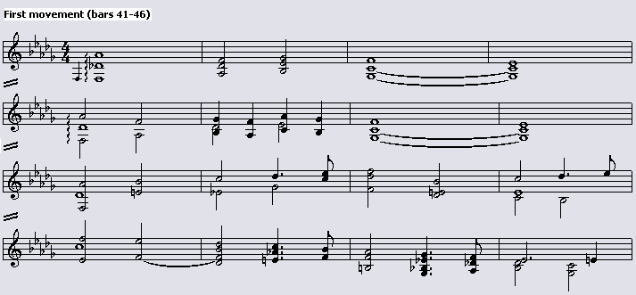

Abraham, like critics before him, also felt that Chopin’s sonata opus 35 was not comparable with the sonatas of the great classical tradition. His reasoning was that Chopin’s conceptions of form and thematic development were too radically different from those of Beethoven and the earlier classical masters who had created the sonata, for him to be able to cast his ideas successfully in a classical form. He sees Chopin’s sonatas as affairs of sequence, variation, and modulation, “…swept along by powerful winds of improvisatory inspiration and worked out with fine attention to detail.” In conclusion, he states that “…here again Chopin must be judged not as an inferior successor of Beethoven but as the brilliant forerunner of Liszt and Wagner.”

Thus far, a sample of opinions concerning Chopin’s opus 35 have been presented and critically evaluated. It is evident that most critics had serious reservations about the work, the most common being a lack of structural coherence and thematic connection between the four movements of the sonata. In connection with the latter, it should be highlighted that this need not necessarily be a criterion for sonata-cycle status, as is the case in the sonatas of Haydn and Mozart. The writings of Hugo Leichtentritt can, however, be interpreted as the beginning of a turning point in the reception of this sonata, as well as the beginning of the shift from criticism to analysis. In Chapters Seven, Eight, and Nine, the works of other analysts who follow on from and expand upon Leichtentritt’s analyses will be examined.

CHAPTER 5

LATER RECEPTION (1940-1996)

The post-Leichtentritt writings on Chopin’s B Flat Minor sonata exhibit a definite change in reception. Although those from the 1930s were still quite negative, by the 1940s most theorists showed a change in reception of the sonata. This led to the general acknowledgement that Chopin’s sonatas opus 35 and opus 58 could be counted among his greatest compositions, which is a far cry from the oft-repeated nineteenth-century reservation that Chopin was not able to master the large-scale forms.

The influential Chopin scholar Arthur Hedley opposed the act of subjecting Chopin’s sonata opus 35 to tests of adherence to “textbook” sonata form. In writings from 1947, he argues that “…an exaggerated respect for the letter of the law governing the mythical ‘true sonata form’ (an invention of the lecture-room rather than of the composer’s workshop) has been the cause of much injustice to the two Sonatas, in B Flat Minor and B Minor, of whose ‘wrongness’ quasi-mathematical proof is to be found in some text-books.” He continues by stating that although these sonatas are not above the law, it is important to discover what law Chopin was attempting to conform with, before deciding that the work “cannot be good, since it does not agree with the principles laid down by Herr Professor X in 1825.”

Hedley believed that because of the fact that Chopin chose to do in 1844 in the B Minor Sonata what he had done in 1839 in the first movement of Opus 35, he intended to write the sonatas in a way that best suited him i.e., using “…long lyrical or dramatic periods rather than the closely reasoned development of short, pregnant themes.” Hedley maintained that this did not imply that Chopin should have left sonata form alone, unless one rules that “…a sonata cannot exist except in the form fixed for all eternity by certain older masters.” He criticises Schumann’s abhorrence of the Funeral March, stating that Schumann missed the whole point of the sonata in that the Funeral March is the central core of the whole work. Like many other theorists in the twentieth century, Hedley believed that it was from the March (written two years before the other movements) that the first movement and Scherzo were derived in that it stimulated Chopin “to embody within the framework of a sonata the emotions which the vision of death aroused in him.”

Herbert Weinstock also attacks Schumann’s critique of opus 35. He maintains that “[t]he literary-minded Schumann would have been less disturbed if Chopin had given the four separate movements coined romantic names.… Calling the B-flat minor a sonata was neither caprice nor jest: it is a sonata by Chopin.” From a performance point of view, Weinstock believes that if the work is played so that it sounds like four separate pieces, the fault is that of the pianist, and not Chopin. He adds that if he “…heard it played…with the complete, over-all, four-movement structural and aesthetic-emotional unity of a Mozart piano concerto or Beethoven piano sonata; then the achievement was Chopin’s – and the pianists.” Unfortunately, Weinstock makes an error here in comparing the four-movement structure of Chopin’s opus 35 with the three-movement form of a Mozart piano concerto; presumably he is attesting to the presence of the structural unity of the sonata cycle in Chopin’s opus 35. In connection with the foregoing, he asserts that Chopin designed the other three movements to go with the Funeral March, and that he conceived them as belonging together. The presence of thematic interrelationships between all four movements of the sonata (as outlined in Chapters Seven and Eight) tends to support this view.

Although he does not illustrate his observation, Weinstock notes the close relation between the second subject of the first movement, the melody of the più lento section of the Scherzo, and the Trio of the Funeral March. He also highlights the importance of the manner in which the Scherzo and the Funeral March are connected, whereby Chopin ends the Scherzo with the melody from the più lento section. This, according to Weinstock, is a perfect bridge between the most agitated and brilliant of movements and the “mournful pomps to come.” This view contradicts, and in a sense disproves, the earlier reservation of James Huneker that the Funeral March and Finale have nothing to do with the first two movements.

Weinstock concludes his discussion of opus 35 by stating that “…the B-flat minor Sonata seems to me one of the perfect formal achievements of music…I believe that by itself, had Chopin written little else, it would entitle him to a position as peer of the greatest artistic creators.” A similar view is echoed by Orga Ates, who states: “Yet [opus 35] can today be seen as one of Chopin’s greatest achievements, a grandly handled piece for which no prose can adequately describe its musical essence or the experiences it seems to embody.” Mareck and Gordon-Smith likewise feel that opus 35 is “…surely one of the great achievements of piano music, in spite of the bathos which bad playing has smeared over the third movement.” Alan Walker calls it a “…noble structure…well in advance of its time,” and expresses amazement at the fact that many eminent musicians failed at first to comprehend it fully. The Chopin scholar Vladimir Protopopov likewise believes that opus 35 is among the best of not only Chopin’s compositions, but also those of the western classical repertoire in general.

Bernard Gavoty seems puzzled by the indifference opus 35 met from the composers Liszt, Schumann, and Vincent d’Indy: “From the first two – whom, however, the scholastic collar hardly choked – a basic severity astonishes us. Why refuse Chopin that which gives such particular color to his imagination: freedom of form, indifference to stereotyped models?” Of d’Indy, Gavoty states that “With my own ears I have heard [d’Indy] maintain at his course at the Schola Cantorum…that ‘it is too bad that Schubert and Chopin were ignorant of counterpoint; this accounts for the poverty of their sonatas.’” This scathing remark with regard to Chopin’s sonatas is in agreement with the generally accepted opinions of that time (i.e., the late nineteenth-century), as presented in earlier chapters. D’Indy’s assertion that Chopin was ignorant of counterpoint is questionable on even a cursory examination of many of Chopin’s scores. For example, the Allegro maestoso from the piano sonata opus 58 shows possibly the clearest influence of Bach in all Chopin’s works, by exhibiting much independence of voice movement. Gavoty maintains that d’Indy and his pupils’ blind confidence in scholarly schemes is far from desirable, and that it “accounts for their perfect, inert sonatas – reinforced concrete to the marrow.”

Gavoty does not agree with the idea that because it does not obey the canons derived from the sonatas of Haydn, Mozart, and Beethoven, opus 35 is an inferior work. He also disagrees with Schumann’s comment that “[o]ne would say that the Polish background has disappeared and that Chopin, by way of Germany, is leaning toward Italy.” Gavoty’s reasoning is that the singing episodes of the sonata have nothing of the cavatinas that liven the arias of Rossini or Bellini. He reiterates that Chopin was a Polish composer and that “…the fate of his fatherland was a constant concern of his.”

Some of the most influential writings on Chopin in recent years are those of Jim Samson. In his discussion of Chopin’s opus 35, Samson does not attempt to “disprove” Schumann; rather, he provides suggestions for the unique characteristics exhibited in this sonata. These will be examined in Chapter Nine. For now, it is worthwhile mentioning one of Samson’s important observations in his 1985 The Music of Chopin, in which he states:

When [Chopin] returned to the sonata in 1839…he had already proved himself a master of other lines of thought, musically speaking. The Sonata funèbre…is a dialogue between these lines of thought and the German sonata principle. Like the Russian symphony, it has been criticised often and vigorously for failing to achieve a result which it never sought.

This last comment echoes Arthur Hedley’s objection to comparing Chopin’s opus 35 to the “textbook” sonata form. Samson notes that the sonata was “…cultivated with greatest energy in Austro-Germany,” which led to attempts to codify sonata compositional principles, “…with implications for pedagogy, criticism and indeed creative process which were not always beneficial.” He cites the Russian symphony as an example, stating that it was viewed as an “…unhappy deviation from, rather than a potentially exciting collaboration with, German symphonism.” He maintains that although a combination of aspects of the symphonic tradition with indigenous thematic material and formal treatments did occasionally lead to undesirable results, the music should be judged in relation to its aims and ideals.

Samson reinforced this view in his 1996 Chopin, in which he states that Chopin’s modelling of his opus 35 on Beethoven’s opus 26 was a response to classical precedent, and that this precedent placed exceptional pressures on the work. Samson suggests that the formal expectations of the Classical sonata were bound to remain unfulfilled in opus 35, as Chopin was trying to create effectively a new kind of sonata, albeit based on the old. This ties in with Chopin’s role in the evolution of the sonata, which will be examined in Chapter Six.

Anatoly Leiken echoes Samson’s contention that unnecessary “exceptional pressures” were placed on opus 35. He observes that the Romantic period saw a significant decline in the number of sonatas being written per composer. Mozart wrote seventy and Beethoven fifty-five, yet Chopin wrote five, Schumann eight, and Liszt only two. Leiken does not interpret this as the Romantic composers’ loss of interest in the sonata, but rather as a reflection of their unease at attempting to reach the Olympian feats of the sonatas of Haydn, Mozart, and Beethoven. He reckons that although the Romantic sonata differs in many respects from the Classical sonata, one should not assume that these changes are for the worse. Rather, they should be viewed as a “…strong urge to renovate a form that had been around for many decades, to make it more spontaneous and less predictable.” It should be mentioned, however, that the sonatas of Haydn, Mozart, and Beethoven are rarely “predictable”, although this may be the case with some of the lesser composers of sonatas in the Classical era.

In a recent work, Jeremy Siepmann makes some interesting comments with reference to the “text-book” sonata-form structures laid down in the codifications by Marx and Czerny. He asserts that few great composers have adhered to “text-book” sonata form, with the result that these structures have usually to be drawn from second-rate works. On the one hand, this is plainly obvious in that the sonatas of Haydn, Mozart, and Beethoven predate the definition of sonata form; they could therefore not follow rules not yet written. On the other hand, however, Rosen has noted that Marx’s codification of sonata form was modelled on Beethoven’s middle-period works. One can therefore conclude that some sonatas of the great composers will show a similarity with the textbook definition, while others will not. Siepmann adds that if Chopin had called his B flat Minor sonata “Fantasy, Scherzo, March and Finale” he might “…have saved himself and history a lot of fruitless trouble.” There is probably much truth in this.

In another recent publication, Charles Rosen critically examines Schumann’s comments and offers some interesting ideas. He questions whether Schumann’s undoubted knowledge that the Funeral March had been written two years earlier than the rest of the work affected his judgement of its unity. On opus 35’s unity, Rosen argues that “…the unity of tone and of harmonic color that holds Chopin’s four movements together is not only impressive, but far surpasses the more arbitrary technique of achieving unity by quoting literally from earlier movements in the later ones, a technique that was popular with many of Chopin’s contemporaries including…Schumann himself.” This highlights the extreme diversity of opinions on one work – from the early notion that opus 35 lacked structural unity, to recent writings that not only attest to the presence of unifying factors in the work, but also the subtle manner in which they are employed.

Rosen addresses the issue of why so much notice was taken of Schumann’s comment in the first place. Chopin was known to have general contempt for most of his contemporaries. On being given a copy of Schumann’s Kreisleriana, he commented favourably only on the design of the cover page (which was, indeed, impressive). Furthermore, this work was dedicated to Chopin. Is it coincidence that Schumann’s negative critique appeared only two to three years after Chopin had reacted unfavourably to Kreisleriana, completed in 1838? The answer is probably no.

Another issue addressed by Rosen is the notion that Chopin was incapable of dealing with large forms. He argues that it might more reasonably be maintained that “ [Chopin] was the only musician of his generation who felt invariably at ease with [large forms] – each of the Ballades and Scherzi is, after all, as long as, or longer than, an average movement of Beethoven.” This view is somewhat simplistic, however, as large forms carry implications of not only length, but also complexity. The Ballades and Scherzi may be long, but are rather simple in structure.

Thus far, a large sample of critical writings relating to Chopin’s sonata opus 35 has been surveyed. These writings, spanning a period of over 150 years, have shown a definite trend of initial negative criticism giving way to a greater understanding of Chopin’s compositional style, and hence a more positive reception. Before embarking on a survey of the various extant analyses of the work, an overview of the history of the sonata cycle is necessary, in order that Chopin’s sonata can be placed in historical perspective.

CHAPTER 6

CHOPIN’S OPUS 35 IN HISTORICAL PERSPECTIVE

Analyses by various commentators such as Leichtentritt, Réti, Walker, and Leiken provide much useful information on Chopin’s compositional style inasmuch as it is connected to the sonata. These analyses are responsible for a general trend of increasingly favourable reception of Chopin’s sonatas in general, especially over the last half-century. It is advantageous, however, to examine briefly the state of the sonata in the nineteenth century (referred to as the “Romantic sonata” by William Newman) in order that Chopin’s style of sonata composition can be placed in perspective. A short investigation into the evolution of Chopin’s sonata style from his early opus 4 to the late opus 65 will also be conducted. While these endeavours cannot prove or disprove the validity of Schumann’s comments, they may shed light on the possible reasons why Chopin intentionally or unintentionally chose to compose a sonata as controversial as opus 35.

William Newman’s 1972 work The Sonata Since Beethoven from his monumental three-volume A History of the Sonata Idea provides a detailed study of the term “Romantic sonata” as well as a history of the origin of the terms “sonata” and “sonata form”. He begins by looking at Romantic views of the sonata, whether as a title, a particular form or an aesthetic problem. He emphasises the importance of the transition, by the mid-nineteenth century, “…from a loose, casual concept of a free, even a fantasy, form to a tight, fixed concept of a highly specific form, specific enough to crystallise in the textbooks and even to become a criterion by which sonatas soon were evaluated.”

According to Newman, few theorists had “…shown more than a hazy recognition of ‘sonata form’ during the Classic Era and up to the late 1830’s.”; only two to three dozen definitions and explanations can be found in writings from the Classical era. He adds that H.C. Koch came closest to such recognition in his explanation of the first movement of the symphony, with, however, an implication that the sonata was somewhat different and more intimate in style than the symphony. A study of Koch’s writings as they appear in Newman yields little in terms of the sonata cycle as a whole. In general, the only requirement that seems to be mentioned in writings from this time is that of contrast between the movements. Suggestions regarding the choice of form and character to be used for each movement were barely touched upon.

Furthermore, dictionary definitions were hazy at best. J.A.P. Schulz’s 1775 discussion of a sonata mentions the fact that it is an instrumental piece consisting of two, three, or four successive movements of different character. He adds that the sonata is the best form with which a composer could depict his feelings without words. Nothing is mentioned about first-movement sonata form, or the form of the sonata work as a whole. This is also evident in a 1755 article by Rousseau.

Newman considers the appearance of an eight-page discussion of “La grande coupe binaire” (“fully-developed binary design”) from Anton Reicha’s Traité de haute composition musicale in 1826 as the next step in the process of recognition of sonata form. Although Reicha does not mention the word “sonata,” nor recognise the ternary implications of the design, he does cover the basic essentials, including the terms “exposition” and “development.” He also establishes the proportions of both parts of the binary design, saying that they should be in a 1:2 or 1:3 relationship. More importantly, he fixes not only the arrangement of the themes in the exposition, but also the key structure.

Newman also refers to Adolph Bernhard Marx who, in 1845, published a detailed 137-page section on “sonata form” in the first edition of Die Lehre von der musikalischen Komposition. He states that Marx “devoted much attention to details of phrase-and-period syntax, he preferred a ternary to a binary concept of ‘sonata form,’ and he included among the other movements the overlapping of types like the ‘sonata rondo’ and the ‘fugal sonata.’”

It was in 1837, however, that Carl Czerny who, in the preface to his opus 600 (a work devoted to the explanation of compositional techniques), implied that he was the first to describe the sonata in any detail. It was only in 1848, however, that this three-volume treatise on composition appeared in print. Newman provides a brief summary of Czerny’s description of the first movement of the sonata, which will be discussed here.

Czerny described in detail, in the forty-nine pages of his sixth chapter, what “must” go into each of the four movements (allegro, adagio or andante, scherzo or minuet, and finale or rondo). He cautioned that in connection with the first movement, “we must always proceed in a settled form. For, if this order were evaded or arbitrarily changed, the composition would no longer be a regular Sonata.” He still viewed the first movement as being in two parts. Its first part consists of the “principal subject,” its extension and a modulation to “the nearest related key,” a “middle subject” and its extension in the related key, and a “final melody” that closes in that key at the repeat sign. Its second part divides into two sections, a modulatory “development” of any of those ideas or a new one, ending back in the original key; and a recapitulation that restates the first part except for abridgements and adjustments needed to remain in the original key. Czerny also discussed the other three movements of the sonata and quoted examples from piano sonatas regarded by him as successful, including those by Haydn, Clementi, Mozart, Beethoven, and Dussek.

The most striking feature of this discussion of the codification of the term “sonata” is that Chopin’s second piano sonata was composed before the concepts “sonata” and “sonata form” (in their modern sense) had been fully recognised as specific terms in textbooks on music theory. As Newman puts it, Czerny’s work provides “an astonishing illustration of the degree to which theory can trail practice. Not until as much as sixty years after some of the masterworks of Haydn, Mozart, Beethoven, and Clementi had appeared…did anyone write an explicit description of what happens in a sonata.” He also recognises the significance of this textbook description as being “a fair abstraction of the still fluid Classic forms.”

The phrase “still fluid Classic forms” has particular relevance here. Sonatas were, for obvious reasons, not subject to rigorous tests of adherence to textbook sonata form until 1826; more probably not until the appearance of Marx’s writings on sonata form in 1845. Composers around the turn of the nineteenth century were writing sonatas under the influence of Haydn, Mozart and Beethoven. The codification of sonata form complicated the situation somewhat in that many of the Viennese sonatas did not conform thereto. Accordingly, composers were faced with a dilemma and were possibly unsure as to how the sonata was to develop further. This could be a reason for the noticeable decline in volume of sonata output in the 1830’s.

The codification process, then, could be viewed as having an obstructive effect on the “still fluid Classic forms.” That being so, it is possible that Romantic composers felt the need to move away from textbook sonata form so as to maintain the fluidity and continual development of sonata form and the sonata cycle. Chopin could be viewed as an integral part of this process; in fact, Newman singles out four composers as the main cornerstones of the Romantic sonata: Schubert, Schumann, Chopin, and Brahms. He argues that their importance can be compared to that of Corelli in the Baroque era, and to Haydn, Mozart, and Beethoven in the Classical era.

It would seem, then, that Chopin subconsciously assimilated the great sonatas of his predecessors over time and adapted the sonata to suit his own style. Although Reicha’s account of the “fully-developed binary design” was published around thirteen years before Chopin composed his B flat Minor sonata, and that frequent references were made from the start of the nineteenth century to “the usual form of the sonata,” the writings of Marx and Czerny had not yet appeared in print. In addition, as noted earlier, theorists devoted “…the lion’s share of attention to the first fast movement, sometimes to the almost total neglect of the other movements.” It was the third and fourth movements of opus 35 that troubled Schumann most, and yet theorists until that time had written little about these movements in a “typical” sonata. Why, then, should Chopin’s funeral march and finale of opus 35 have evoked such criticism, given that the sonata cycle was still an evolving genre not yet described in great detail in theoretical works? An answer might be that their content was not the norm of the day, yet how can a form develop and evolve if the norm is continually used?

At this point, a general discussion of Romantic era opinions relating to the sonata would be useful in highlighting other possible reasons for the emergence of a sonata of the form of Chopin’s opus 35. It is a known fact that throughout the Romantic era “there was a stream of pessimistic opinions to the effect that the sonata had already or would soon come to its end.” According to Newman, the number of sonatas being composed declined precipitously in the 1830’s. By the 1850’s a rise in interest in the sonata was once again evident, although pessimistic opinions regarding the status and prognosis of the sonata outnumbered the optimistic ones.

Examples of such negative opinions are in abundance. Newman mentions an 1832 review of Pio Cianchettini’s Opus 26 begins: “A sonata once more!-The newest fashions after all are but old ones forgotten and revived.…” Schumann’s view on the subject from 1839 is particularly interesting:

Strange that suddenly there are mostly unknowns who are writing sonatas… It is easy to guess what moves the former, mostly young artists. There is no worthier form by which they might introduce and ingratiate themselves [better] in the eyes of the finer critics. But in consequence most sonatas of this sort can be considered only as a kind of testing grounds, as studies in form. They are scarcely born out of a strong inner compulsion… Occasional lovely manifestations of this sort are sure to appear here and there, and [some] already have done so. But otherwise it seems the form has run its course, and this [drop-off] is certainly in the order of things, and [what is more] we should not have to repeat the same [form] year after year and at the same time deliberate over the new. So one writes sonatas or fantasias (what matter the name!); let one not forget music and the rest will succeed through our good genius…

It is clear that Schumann felt that the sonata as a genre was becoming stale, and that it was used to a large extent as a vehicle for recognition among younger composers. Even he called for new forms, saying that the sonata “had run its course.” Why then, when presented with a sonata of the originality, imagination, and beauty of musical ideas of Chopin’s opus 35, was his reaction so negative? He was requesting that “…we should not have to repeat the same [form] year after year” – did Chopin’s second piano sonata not fulfil this wish? One would have thought that at the lowest depths of the decline of the sonata, Schumann would have welcomed such an interesting work; a work that was a far cry from the “textbook style” sonatas of younger composers which were “scarcely born out of a strong inner compulsion.”

Other views echoed that of Schuman. In 1843 the Leipzig publisher C.A. Klemm preferred to issue Schubert’s Sonata D.459 as Fünf Klavierstücke, apparently because the title “sonata” had become old-fashioned. In 1855 the French lexicographer Charles Soullier regarded the sonata as having “…died with the 18th century that produced it so abundantly.”

Notwithstanding these negative opinions, one view did remain constant in the Romantic era. The sonata was seen “…as an, if not the, ideal of both technical and musical achievement to which a composer might aspire - usually an ideal that related to Beethoven’s image and one that could not be approached other than with the highest standards and greatest sincerity.” An important aspect of the Romantic sonata’s association with high ideals was the constant quest for originality. This quest, already developed in the Classic era, was still present in the early-nineteenth century, when a reviewer wrote that a sonata could not be a mere routine; there must be some caprice, exploration, and originality, but not to excess. The numerous neutral or less favourable reviews of sonatas at the time repeatedly used the phrase-”good craftsmanship, but lacking in originality.” The interpretation of originality, if not excessive is of course open to debate, but nevertheless suggests conservative limitations in the quest for originality.

Of the sources consulted, it cannot be ascertained whether the general state of the sonata at the time of the composition of opus 35 influenced Chopin in any way, although one could argue that Chopin’s style anyway derives in the main from the works of his predecessors. The conclusion that Chopin felt that the sonata as a genre was becoming stale and was in need of something new and controversial to rekindle interest therein is speculative and has not been substantiated. Certainly his letter to Julian Fontana concerning the B flat Minor Sonata shows no evidence of this. It could certainly be a matter of coincidence that opus 35 appeared when the sonata, as Schumann said, “had run its course.”

That said, the analyses of Chopin’s opus 35 will now be examined, beginning with the early ones of Hugo Leichtentritt in Chapter Seven.

CHAPTER 7

THE EARLY ANALYSES – LEICHTENTRITT AND RÉTI

As stated in Chapter Four, one of the first comprehensive analyses of the works of Chopin was that of Hugo Leichtentritt in 1921. The significance of a German musicologist undertaking a project of such a scale has already been mentioned in Chapter Four. Leichtentritt’s analysis of the B flat Minor Sonata is quite significant in that it is almost always referred to in subsequent analyses of the work by other analysts. Many of his opinions and analytical discoveries were used to great advantage as a basis for further investigation in later writings. Alan Walker views Leichtentritt’s analyses as extremely important for their time in that when it was still “fashionable to regard Chopin as a mere dreamer, a loose musical thinker,” Leichtentritt revealed Chopin’s structural mastery to “a generation who had not yet heard the news.”

A significant portion of Leichtentritt’s analysis of the opus 35 sonata deals with Chopin’s harmonic idiom. His preoccupation with harmonic analysis can in some cases be seen as superfluous, in the sense that any musically educated reader would be able to discern Chopin’s underlying harmony for themselves. The issues dealt with by Leichtentritt in his analysis will be examined only inasmuch as they contribute counter-arguments to the negative reception of the late-nineteenth and early-twentieth centuries. A comprehensive survey of his analysis will thus not be undertaken.

Leichtentritt’s understanding of the function of the introductory four bars of the first movement of opus 35 is that of delaying the entry of the first subject in order to create tension, the degree of which is intensified by the metrical and harmonic irregularity of these bars. Furthermore, he believes that the work begins on the fifth bar of an eight-bar phrase. Right from the start, then, Leichtentritt highlights the importance of the first four bars. His observations in connection with the latter have been examined in further detail in more recent writings such as those of Réti, Walker and Leiken.

Leichtentritt also examines the issue of thematic unity in the sonata. He observes that derivatives of the first subject manifest themselves in the second subject, as well as the accompaniment to the melody of the second subject. As shown in Example 2, the second subject grows organically out of the first through the rhythmic change of the first subject. Example 3 shows how the accompaniment of the melody of the second subject makes use of a new rhythmic variant of the first subject. A further link is shown in Example 4, where the material in the right hand of bars 81 to 82 also derives from the first subject. Leichtentritt calls this phenomenon of thematic integration the “principe cyclique”, and notes that it was used by Beethoven in his Piano Sonata Opus 81a and last quartets as well as by Liszt in his sonatas.

Example 2: Derivation of the second subject (top stave) from the first (bottom
stave)

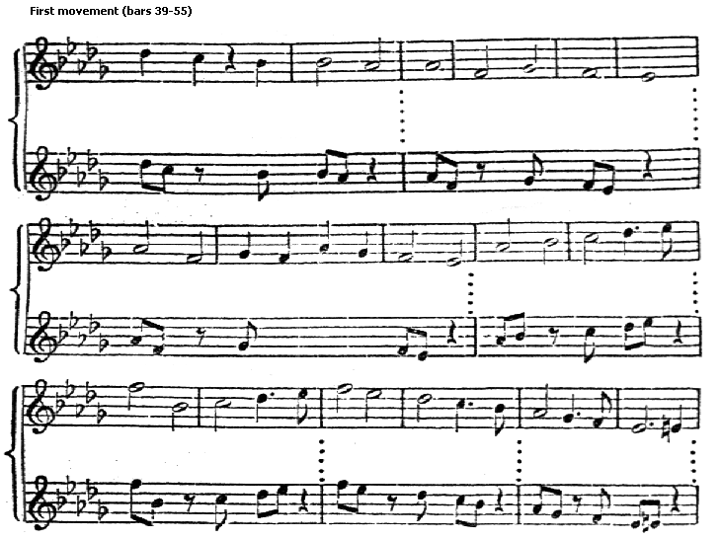

Example 3: Derivation of the accompaniment figure (top stave) from the first
subject (bottom stave)

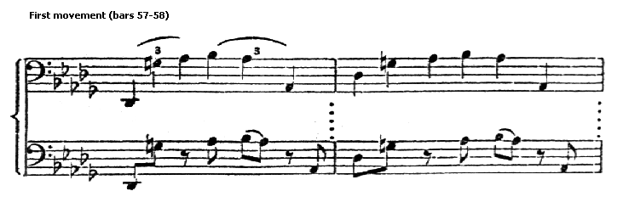

Example 4: Derivation of the third subject (top stave) from the first (bottom
stave)

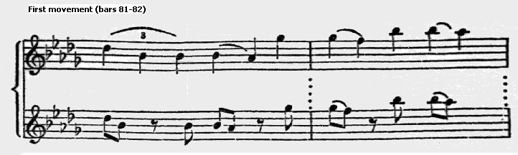
Leichtentritt also highlights the presence of rhythmic interconnection between themes. He emphasises the importance of the rhythm of the first subject of the first movement in that variants thereof are found in the themes of the Scherzo and the March. As shown in Example 5, rewriting the rhythmic outline of the first subject in 4/4 reveals how extensively this rhythm is used throughout the Scherzo in various forms. The octave passage in bars 183-188, the accompaniment figure of the Trio, and the main theme of the Scherzo beginning in bar 1 are all rhythmically derived in some way from this first subject. Similarly, a link between this subject and the main theme of the March is also evident, as shown in Example 6:

Example 5: Rhythmic interconnection between themes
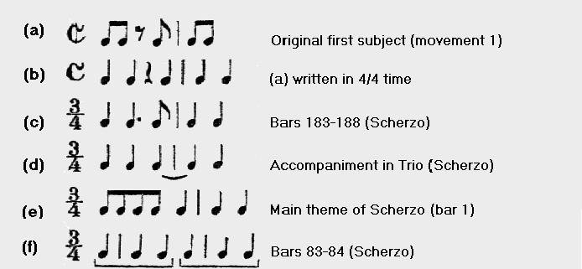
Example 6: Rhythmic link between the first subject of the first movement
and the main theme of the Funeral March

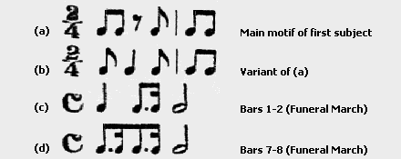

Leichtentritt’s view of Chopin’s harmonic idiom is interesting in that he sees the extensive use of chromaticism (especially in the development section of the first movement) as an important precursor to the harmony of Wagner. With reference to the development section itself, he interprets it as a free fantasy over the main subject and distinguishes it from the thematic developments of Beethoven. Leichtentritt also highlights Chopin’s effective manner of modulation at the end of the Trio section of the second movement in bars 183-188 (see Example 7), pointing to a similar usage by Beethoven at the beginning of the third Leonora Overture. He observes that the octaves between the two hands have the effect of a darkening of the harmonic meaning of single notes. These notes also function as a means of delaying the re-entry of the Scherzo’s main theme in E flat minor, as well as obscuring the overall harmonic function of the link between the Trio and Scherzo. This state of limbo is abruptly ended by the emergence of the E Flat minor harmony that provides a sense of relief to the listener as the repeat of the familiar material of the Scherzo begins in bar 189. It can thus be seen that Leichtentritt’s thorough examination of Chopin’s choice of harmonies sheds new light on Schumann’s objection (see page 84) that Chopin’s use of arbitrary, wild chord writing and excessive dissonance renders the detection of musical goals more difficult. The difficulty in ascertaining these goals is precisely the effect Chopin wished to create, and should not be interpreted as a compositional weakness.
Example 7: Modulation from the Trio to the Scherzo in the second movement

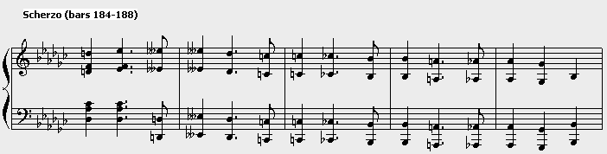

The next important section of Leichtentritt’s analysis, one that has been repeated ad nauseum by hosts of other writers, is that of explaining the absence of the first subject at the beginning of the recapitulation section of the first movement. Leichtentritt maintains that the first subject generates such a significantly large portion of the development section that to recapitulate it would be repetitive and ungainly.

Apart from the Finale, which will be examined in Chapter Ten, the final point of Lechitentritt’s analysis worth highlighting is that of Chopin’s manner of linking the Scherzo and the Trio, a feature examined previously in the work of Herbert Weinstock on page 25. Leichtentritt maintains that the beginning of the Funeral March is prepared by the slow ending of the Scherzo, by means of an expertly placed ritardando (beginning bar 277) at the end of the Scherzo and the changing of time signature from 3/4 in the Scherzo to 4/4 in the March. The effect of this is that the March is heard as a continuation of the ritardando of the Scherzo owing to the stretching of the time signature and broader tempo. This is illustrated in Example 8:

Example 8: The link between the Scherzo and Funeral March

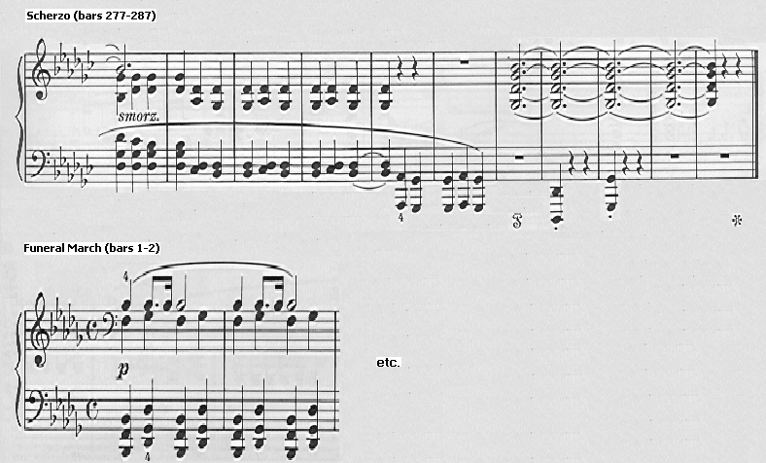

The revelatory aspects of Leichtentritt’s work having been explored, the next important analysis of Chopin’s opus 35 will now be examined – that of Rudloph Réti. His analysis is based on a form-building element considered by him as being almost completely neglected by the theoretical community at the time. This is the sphere of thematic or “motivic” structure, which, when applied to Chopin’s second piano sonata, reveals how thematically unified this work really is.

One of the principal reservations expressed by earlier critics about opus 35 was its apparent lack of thematic and organic unity between the four movements. Réti’s analysis seems to provide overwhelming evidence to the contrary. However, this should be seen in perspective, as Réti is clearly using Chopin’s opus 35 as a medium for proving the validity of his analytical method, and not as a means of rehabilitating Chopin. The uncovering of thematic links between subjects and movements should always be viewed with one important issue in mind: that by a process of reduction, it is often possible to demonstrate a link between any two subjects. In so doing, an analyst might be reading an affinity that is coincidental, not consciously or subconsciously motivated. Attention is drawn below to instances in Réti’s analysis where it appears that he has overly manipulated data to fit his claims.

Réti, like Leichtentritt, begins his analysis by exploring the importance of the introductory four bars. He attests to their structural importance, noting that: “The variegated and fantastic thematic picture Chopin manages to evolve from this inconspicuous introductory shape is almost incredible.” He illustrates the link between the introductory passage (Grave) and the first subject by showing the contours of various parts of this subject, as shown in Example 9. Note how part (d) of this example is almost an exact replica of the grace-note phrase in the bass of bar 3 of the Grave (e).

Example 9: First movement: Link between the contours of the first subject
and the introductory motif

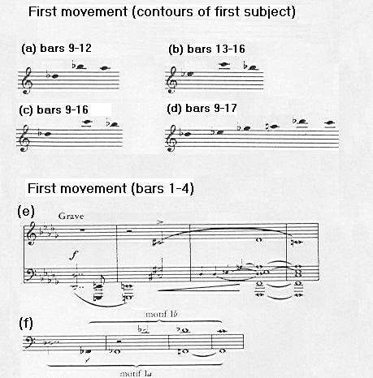

Réti also discusses the importance of the motives in the second half of the first subject. Example 10 shows how he reduces this section to a phrase formed by a stepwise descent of four notes. Here again he illustrates unifying aspects of the first and second halves of this theme, where motif II is a “quasi-inversion” of motif I. Furthermore, the bass accompaniment of the first subject forms a line expressing inversions of motives I and II, as shown in Example 11. The detailed analysis of this first subject reveals that not only the motivic detail, but also its wider melodic line are derived from the original thought of the Grave, to which merely one new phrase (motif II) is added.

Example 10: Outline of bars 17-21 of the first subject of the first movement and
their relation to Motif I of the Grave

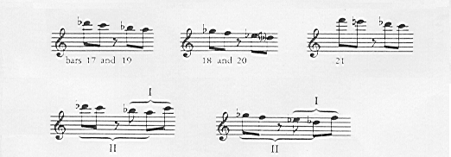

Example 11: Bass accompaniment of the first subject (bars 9-23) of the first
Movement showing its relation to motifs I and II

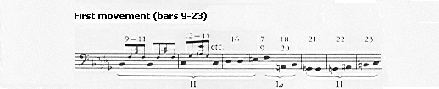

Like Leichtentritt, Réti notes the link between the first and second subject of the first movement. He observes that the beginning of the second subject is actually a “…greatly slackened reiteration of the nervous, agitated first theme,” as shown in Example 12. He also illustrates that the connection of the second subject to the work as a whole is not confined to is first three notes. Example 13 shows that the varied repetition of this subject (beginning in bar 57) can be seen as a derivative of the introductory motif in that the motivic change from the sixth to the seventh is included as an ornament in the melodic line (the G-flat). Thus both the first and second subjects are derivatives of the introductory motif. Réti emphasises the significance of this discovery, saying that these lines of Chopin, “…so often described as the archetype of purely emotional outpouring, are firmly rooted in structural ground.”

Example 12: The relationship between the first and second subjects of the first
movement



Example 13: Ornamented version of the second subject (bars 57-59)



The third subject (beginning in bar 81) can be seen as a combination of the first and second subjects, as shown in Example 14. The brackets show the affinity between the second and third subjects, while the beginning of the third recalls that of the first.

Example 14: The relationship between the first, second, and third subjects of
the first movement

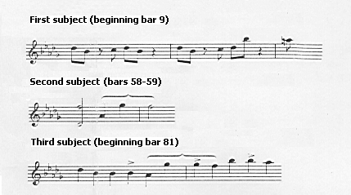

Réti regards these three themes as the basic material from which the whole movement is built in constant ornamentation, yet “with an almost rigid adherence to the basic idea.” This is consistent with what most analysts would observe with regard to a movement in sonata form. Furthermore, he emphasises the fact that once the unified structure of the first movement has been clarified by the analyses presented thus far, “…the design of the following movements as the natural outgrowth of the first cannot be mistaken.”

The next important point emphasised by Réti is that of the effective manner in which Chopin connects the first movement with the Scherzo. By comparing the coda of the first movement as it rises from d² - b flat² – a² (bars 230-236) to the Scherzo theme, the similarity in outline becomes obvious, as shown in Examples 15(a) and 15(b):

Example 15: Similarity in outline between bars 229-241 of the first movement
and bars 1-8 of the Scherzo

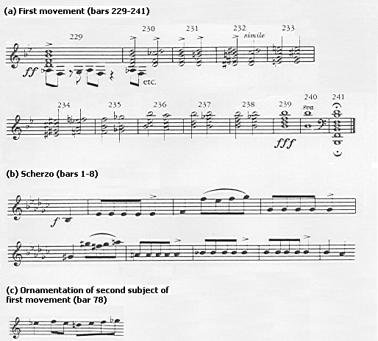

Réti illustrates that, starting in Example 15(a) with the D-sharp in bar 232, and in Example 15(b) with the E-flat in bar 1, and embroidering the line of Example 15(a) with the ornamentation of the second subject from the first movement (Example 15(c)), the Scherzo theme is revealed. On the absence of the opening D of the coda of the first movement in the Scherzo, Réti explains: “As Chopin apparently planned the Scherzo in E-flat, yet wished to carry over the essential pitch of the concluding group from the preceding movement, he had almost no alternative to omitting the opening D.” Furthermore, the last melodic note of the first movement is a D; if Chopin did not feel that this note was important as far as thematic design was concerned, it is likely that he would have ended the movement on a B flat, the note to which the whole group tends. Réti also believes that Chopin had Motif Ib from the Grave in mind when he formed the Scherzo theme. Example 16 shows the material from bars 9 to 11, which expresses motif I in its full course from D-flat to B-flat to A-flat.

Example 16: Use of motif Ib in the Scherzo

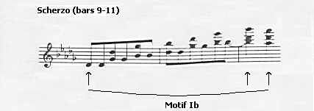

The links do not end here. As illustrated in Example 17, motif II emerges next, in bars 17 to 20, though the stepwise descent of four notes is adjusted to the 3/4 rhythm of the Scherzo.

Example 17: Use of motif II in the Scherzo

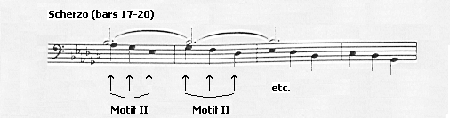

If motifs I and II are to be found in the first subject of the first movement and the main theme of the Scherzo, it is possible that the Trio of the Scherzo would reflect the first movement’s second subject. Comparing the latter reveals that this is indeed the case, as shown in Example 18:
Example 18: Similarity between the second subject of the first movement and
the Trio theme of the Scherzo

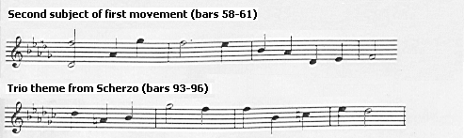

Onto the third movement, yet another interesting link is to be found. If the constant note repetitions of the main theme of the March are ignored, the full motivic contour of the first subject of the first movement in its original key clearly emerges, as illustrated in Example 19. The bracket covering the last five notes of the theme of the March indicates the appearance of motif II:

Example 19: Similarity between the first subject of the first movement and the
main theme of the Funeral March

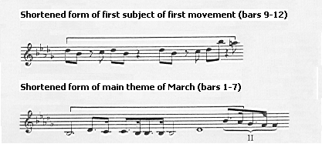

Réti’s major revelation concerns the Finale. He states that “The design of the Finale is so strikingly in accord with the idea of the Allegro theme that it really is surprising that at least this analogy was not noticed long ago.” He is referring to the fact that both themes follow the same pattern, as shown in Example 20. Furthermore, the ensuing parts exhibit characteristics of motif II, as illustrated in Example 21:

Example 20: Similarity between the first subject of the first movement and the
first four bars of the Finale

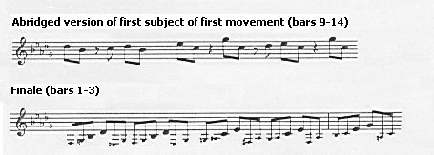
Example 21: Motif II as it appears in bars 5 and 7 in the Finale

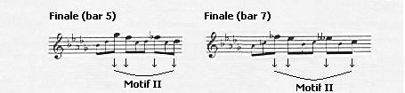

Réti even manages to find hints of a true cantilena as the second theme in a movement characterised by fast, continuous triplet quavers. The idea of such a melodious theme is evident in the second section of the Finale (bars 23-30), exactly when it is due, through figurations shown in Example 22:

Example 22: Hints of a melodious second subject in the Finale

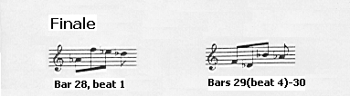

Réti emphasises the fact that Chopin’s music, while exhibiting expressive and romantic qualities, is firmly entrenched in thematic homogeneity and thematic transformation. These transformations, he adds, “become architectural forces, and, indeed, engender musical form.”

On the results of his efforts, Réti concludes:

Guided by these structural clues, the compositional process through which the work must have grown becomes strikingly transparent. We can imagine a musical thought, pregnant both with emotional impulse and with structural possibilities, revolving in the composer’s mind. Visions flash up of the various configurations and moods which this thought may assume, and thus different sections and movements take shape.

The results of these two major analyses by Leichtentritt and Réti show a disagreement with certain of the reservations with regard to opus 35 that were uncovered in earlier chapters. The relevant criticisms are:

- The fact that Chopin was not comfortable in using a sonata (implied in Schumann’s critique in Appendix A);
- The fact that the last two movements have no connection with the first two (Huneker, page 18);
- The lack of organic or thematic unity between the four movements (Hadden, page 19);
- The fact that the Funeral March does not belong to the rest of the work (Schumann’s critique in Appendix A);
- The finale is mockery and not music (Schumann’s critique in Appendix A);
- Using the term “Sonata” to describe four seemingly unconnected pieces (Schumann’s critique in Appendix A/Niecks, page 15/Huneker, page 18).

Furthermore, the harmonic analysis of Leichtentritt unravels Chopin’s unusual use of harmony, and places Huneker’s claims of wild chord writing in perspective. It would seem, then, that there is nothing much else left to uncover, save for a more in-depth investigation of the structure of the finale. That may be the case; yet analyses of this sonata were published in the latter half of the twentieth century, revealing further interesting features. These analyses will be the subject of discussion in Chapter Eight.

CHAPTER 8

FURTHER ANALYSES - WALKER AND OTHERS (1966-1990)

In Frederic Chopin: Profiles of the Man and the Musician, Alan Walker devotes a number of pages to Chopin’s second piano sonata in his chapter on “Chopin and Musical Structure.” He, like Réti, emphasises the importance of the introductory bars, stating that they determine “…the thematic destiny of the entire work.” Walker interprets the falling diminished seventh and rising second in the bass clef of the Grave as “…the cells out of which Chopin’s intuitive genius builds one of his most ‘spontaneous’ works.” This motif is shown in Example 23(b):

Example 23: Derivation of motif (b) from bars 1-4 of the first movement (a)

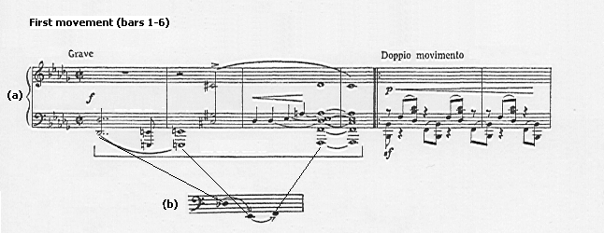
Building on Réti’s analysis of the first subject of the Allegro, Walker states that an octave transposition of the first three notes of this subject shows that it clearly derives from the first three notes of the work, as shown in Example 24. Like Leichtentritt and Réti, he points out the derivation of the second subject from the first, where the first few notes of the second subject form an augmented version of motif X. This is illustrated in Example 25. Walker adds that although the extreme contrast of character of the two subjects could hardly be greater, the second sounds inevitable because of this strong thematic link.

Example 24: Derivation of the first subject

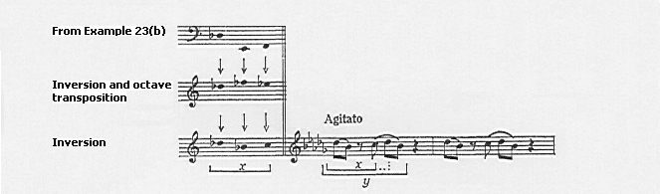

Example 25: The use of motif x (Example 24) in the second subject

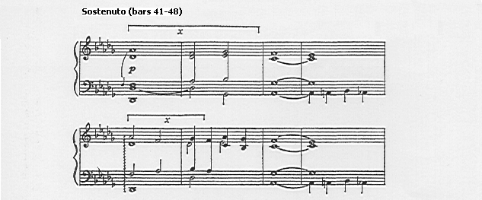

Not mentioned in the previous chapter is yet another connection between the first subject and the final bars of the exposition. Example 26(b) shows the melodic outline of bar 99 near the end of the exposition; when inverted, it is an exact replica of the first four notes of the first subject:
Example 26: Derivation of bar 99 from the first subject

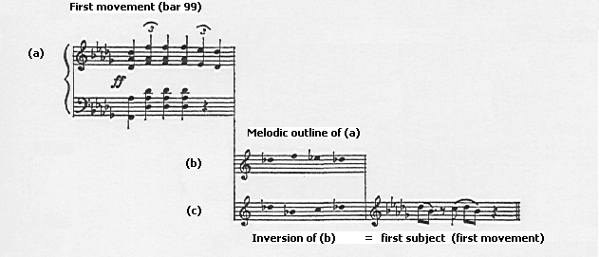

Walker also emphasises the importance of the tempo relationship between the Grave (bars 1-4) and Doppio Movimento (beginning bar 5) in the first movement, i.e., that bar 5 onwards is exactly double the speed of the first four. By doing so, he gives credence to his opinion that the Grave is not something merely “tacked on” at the beginning, and that it should not be played in a slow, improvisatory manner.

Walker is of the opinion that the closely-knit argument of the development section of the first movement, which is based almost exclusively on the first subject, disproves the notion that Chopin could not develop his themes. Example 27, taken from bars 137 to 140, shows how Chopin uses the introductory motif simultaneously with the first subject in the same passage:

Example 27: The three-layered structure beginning bar 137 in the development

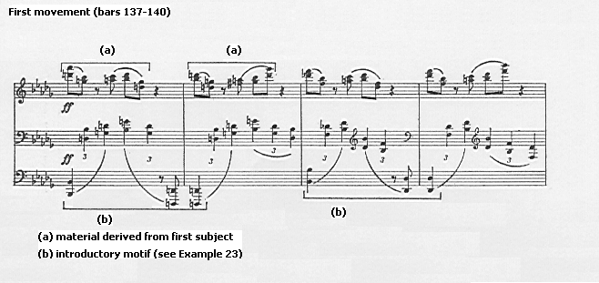

The importance of the minor third (the inversion of the diminished seventh of Réti’s motif Ia on page 46) as a “background unitive force throughout the sonata” is also emphasised by Walker. He notes that the first few bars of the Scherzo show rising minor thirds, while bars 15 to 20 shows a restoration of balance in the use of falling thirds, as shown in Example 28:

Example 28: The use of the minor third in the Scherzo

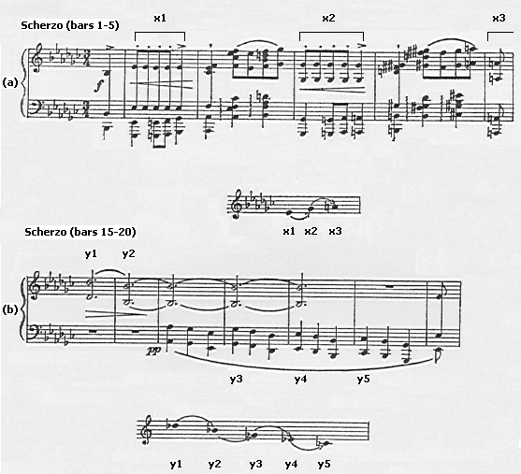

Another thematic link noted by Walker, one that does not appear in the writings of Leichtentritt or Réti, is the subtle integration of the strongly contrasted Trio to the Scherzo itself. Example 29 shows the striking similarity between the concluding bars of the Scherzo and the theme of the Trio. In addition, Walker notes that the Trio theme also looks forward to the Trio section of the Funeral March, as illustrated in Example 30. Thus this Trio theme is strongly linked thematically not only to the Scherzo but also the Funeral March:

Example 29: Thematic integration of the Trio with the Scherzo

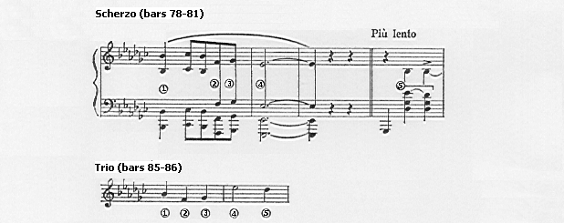

Example 30: Link between the Trio theme of the Scherzo and the Trio theme of
the Funeral March

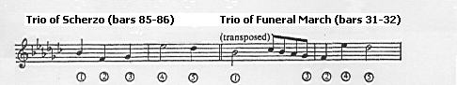

Walker expands on Réti’s discovery of the thematic link between the first subject of the first movement and the main theme of the Funeral March. He illustrates that the melodic contour of the opening bars of the Funeral March is not only derived from the first movement, but is in fact a strict retrograde motion to the first subject of the Allegro, as shown in Example 31. Walker calls this “creative integrity of a high order.” Others, however, may interpret this as note manipulation.

Example 31: Link between the main subject of the Funeral March and the first
subject of the first movement

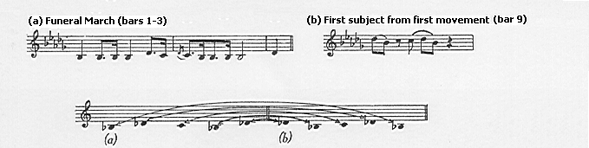

Having already highlighted the importance of mediant relationships as a unifying source in this sonata, Walker goes even further to show that no fewer than six of the sonata’s themes begin on the mediant degree itself, as shown in Example 32:

Example 32: Use of the mediant degree in various subjects

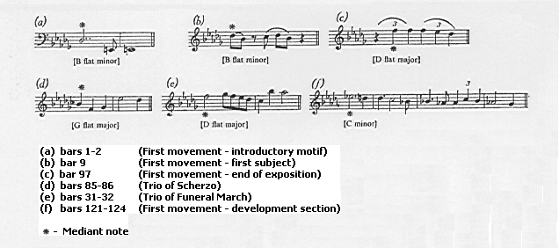

Another revelation by Walker awaits: he observes that the falling seventh-rising second interval of Réti’s motif Ia is present in the seemingly athematic, incomprehensible Finale. Example 33 shows that the notes D-flat, E, and F beginning in the second half of bar 1 of the Finale are exactly those of the introductory notes to the entire work.
Example 33: The use of the introductory motif in the Finale

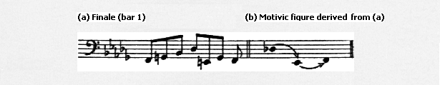

Walker also believes that one of Chopin’s chief contributions to sonata form is the intense compression of his recapitulations. In this regard he discusses the omission of the first subject from the reprise of the first movement, which, in his opinion, is not a “structural weakness,” as perpetuated by conventional wisdom, but “a salutary lesson in how not to compose.” Furthermore, he regards this structural compression as an “unconscious function of creative mastery.”

Walker’s comments on the sonata on a general level are particularly interesting and relate directly to Chopin’s opus 35. He calls the sonata “a story of musical form from Bach’s E Major Violin Concerto to Schoenberg’s First Chamber Symphony.” He explains that the divisions between movements gradually collapsed under the creative pressure of geniuses ranging from Bach to Schoenberg. What began as a multi-movement form, with each movement having its own character, developed into a greatly compressed form two hundred years later. This manifested itself in expositions and recapitulations becoming ever more developmental, separate movements being linked and penetrating one another, and the assembly of every possible character under the name “sonata.” He concludes by stating that sonata form has always been “on the move,” and that Chopin was one of those who helped it along.

Having surveyed a rather in-depth thematic analysis by Walker, other analytical writings on Chopin’s opus 35 sonata will now be reviewed. In an article largely based on the work of Réti, Rudolf Klein makes note of Chopin’s invention of very concentrated themes, a phenomenon already noticeable in his early C Minor Piano Sonata Opus 4. In addition, as already noted by Réti, Klein observes that Chopin’s themes are all derived from a few basic motives. This is in agreement with Walker’s view that, in general, the sonata was subjected to a large amount of structural compression in the eighteenth and nineteenth centuries.

In a monumental dissertation from 1981, John Bollinger uses integrative and Schenkerian analyses to investigate the relationships among unifying compositional devices within Chopin’s opus 35. His work involves the integration of several analyses, a summary of which follows:

- Foreground-Vertical-Linear Analysis. This shows the fusion and interplay of the unifying intervals (the major and minor third) of the Sonata within the pianistic texture.
- Compositional-Structure Outline. This shows the basic structure of each movement, including details of subject material, key changes, and the demarcation of each movement into its respective sections.
- Chromatic-Scale Analysis. This uncovers another unifying device in the Sonata: the ascending and descending chromatic scale as it occurs in each of the four movements.
- Diatonic-Major and Melodic-Minor Scale Analysis. This shows the importance of major and minor scales as unifying devices in each of the four movements.
- Reconstruction Analysis. This involves the juxtaposition of material notated in sharps and flats in the first, second, and fourth movements in order to show chord-function continuity.
- Middle- and Background Schenkerian Sketches. These corroborate the integrative analyses, and include sketches of each movement as a separate entity, as well as a final unified sketch of the entire Sonata.

While it is beyond the scope of this dissertation to enter into detail concerning these analyses, Bollinger concludes that Chopin’s opus 35 is a “totally integrated composition.” He identifies the most important unifying device of the sonata as the compositional relationship of the Funeral March to the other movements, adding that the March “…strongly dictates the compositional outlines of the outer three movements.” This is consistent with the fact that the March was written two years prior to the rest of the work. Bollinger also identifies the utilisation of the major and minor third for theme construction and harmonic development as the other important unifying device. These conclusions are in agreement with the work of Réti and Walker mentioned earlier.

Dammier-Kirpal’s discussion of the seven large-scale cyclic works of Chopin contains an interesting thought regarding the connection between Chopin’s opus 35 and Beethoven’s sonata opus 26. She, like Leiken (see page 7), attests to Beethoven’s influence on Chopin, pointing out the striking similarity between the order of movements in these sonatas. Dammier-Kirpal believes that the contrast between the Funeral March and the Finale of Beethoven’s opus 26 portrays the same impression as that of Chopin’s opus 35 – “like chatting after the march.” What surprises her though, is what Beethoven, the undisputed master of the sonata, did, Chopin did years later, only to be rebuked, thereby causing the appearance of scores of analyses attempting to explain what was perceived as a problematic relationship between the movements. Further evidence regarding Beethoven’s influence on Chopin is the fact that Beethoven’s opus 26 was one of Chopin’s favourite sonatas in that he played, taught, and analysed its structure for his students more often than he did any other of Beethoven’s sonatas.

In his 1985 article “Chopin und die Sonate,” Joachim Kaiser raises an interesting and valid point with reference to Schumann’s reservation that the four movements of opus 35 cannot collectively be termed a “sonata.” He observes that if the Scherzo of opus 35 is compared to any of Chopin’s four stand-alone Scherzi, a huge contrast is evident. Unlike all four stand-alone Scherzi, which contain a vehement coda and end in a triumphant manner, the Scherzo of opus 35 is rather tame by comparison. This is evident in the quiet ending of the movement, as the melody from the Trio enters and slowly dies away. The feeling of expectation or questioning here suggests that the Scherzo has been moulded to fit the bigger context of the Sonata. This, in turn, provides further substantiation for those who opposed Schumann and Huneker’s view that the four movements of this sonata were seemingly unconnected and thus cannot collectively be called a “sonata.”

Charles Rosen raises an important issue with regard to the introductory four bars of the first movement of opus 35. He notes that a glance at the autograph in Warsaw shows that the repeat markings in almost every edition appear in the wrong place – bar 5 instead of bar 1. This, according to him, makes “awkward nonsense of an important moment in the opening movement.” He believes that the repeat is clearly intended to begin with the first note of the movement, or else the harmonic change between the cadence in D flat major at the end of the exposition and the beginning of the accompaniment figure in bar 5 makes no sense. Thus the opening four bars serve a double function: they are a dramatic beginning, and a transition from the end of the exposition back to the tonic.

Having examined the work of various commentators since the 1960’s, recent publications of two influential Chopin scholars of the last decade or so will now be investigated. These are the writings of Jim Samson and Anatoly Leiken, the work of whom has contributed further to the understanding of Chopin’s compositional idiom as it relates to the sonata cycle. This material will be examined in Chapter Nine.

CHAPTER 9

RECENT WRITINGS – SAMSON AND LEIKEN

These commentators have contributed significantly to the understanding of Chopin’s music in the last fifteen years, and for this reason their comments and analyses with respect to Chopin’s second piano sonata are included in a separate chapter. Their writings are particularly informative and seldom constitute a mere rehash of the works of others.

In his 1985 The Music of Chopin, Samson discusses the issue of unity in this sonata, and goes a step further than simple thematic interconnections between movements. He emphasises that the concept of “unity” is a highly problematical notion in music, and that there are various approaches that may be used to investigate this issue. He quotes Jozef Chominski, who states that opus 35 is

…in reality a synthesis of Chopin’s earlier achievements within the framework of the four-movement sonata. The four-movement scheme provides in short a context within which the figurative patterns of the studies and preludes, the cantilene of the nocturnes and even the periodicity of the dance pieces may be drawn together.

Protopopov adds to this argument asserting that Chopin transformed the sonata cycle in a significant manner. In particular, he mentions that, like Beethoven, whose willingness to introduce the fugue into his own later works led to its permeation through to his works using sonata structure, Chopin’s use of the nocturne finds its way into certain themes of the sonata cycle.
This idea that Chopin adapted his earlier achievements to the framework of the sonata can, to some extent, explain the unusual nature of the Finale. Chominski notes that comparing the Finale of opus 35 with the E Flat Major Prelude opus 28 no. 19 shows numerous similarities. Both have a similar texture (i.e., a single line in triplet octaves); they are almost identical in length (75 and 71 bars respectively); and both end on a fortissimo chord. Although it may be true that the Prelude’s triplets are more focused harmonically in that they provide support for the top-voice melody (which is not the case in the Finale of opus 35), the comparison can render the Finale less “futuristically athematic…without precedent in the history of the keyboard.”

As far as the first movement is concerned, Samson demonstrates that the external pattern of the movement respects the main sonata-form outline, save for the avoidance of a “double reprise” (which will be examined in due course). He does, however, highlight the fact that the dynamic scheme is subtly different from that of the Classical sonata. In connection with the latter, he observes that the stark character contrast between the stormy first subject and the beautiful second subject of the Allegro of opus 35 intensifies such inclinations of the Classical sonata to the extent that they take precedence over tonal dialectic. The result is a “romantic distance” between the two subjects rather than the classical ideal of polarity (which would ultimately demand a resolution). With reference to the development, Samson notes that the necessary instability is created through shifting tonality and breaks in continuity, as is the case in many other sonatas. He maintains that the power of the main climax here is significantly large, and is made even greater by the intensity achieved through concentrated motivic working and the use of a three-tier stratification of texture. This is evident in Example 27 (see page 59), where the introductory motif, the first subject, and a middle line of crotchet triplets are employed simultaneously.

Particularly interesting is the reason Samson offers for the lack of the first subject in the recapitulation of the first movement. He dismisses the oft-quoted opinion that its extensive use in the development renders a repeat in the recapitulation redundant, stating that, by the same token, many a Mozart movement would exhibit thematic redundancy. Rather, he believes that the reason lies behind the choice of strongly contrasting characters for the first and second subjects of the exposition; this, in turn, has a profound effect on the overall shape of the movement.

The function of the Classical exposition is to present a tonal opposition; the first subject is quoted in the tonic, while the second is in a key other than the tonic. This tension is resolved in the recapitulation with the return of the second subject in the tonic key. The first movement of Chopin’s opus 35, however, is conceived differently. Samson maintains that the function of the lyrical second theme is to resolve the tension and drama of the first theme, and that the response to the exposition (i.e., the development and recapitulation) preserves this relationship. Therefore, the drama and energy of the first subject is heightened by motivic development while the stability and calm of the second subject is achieved through a return to the tonic key. The result is a model with an overall shape that inevitably results in a slackening of formal and tonal bonds of the Classical sonata. This accounts for Samson’s proposition that the intra- and inter-movement motivic and thematic links (as illustrated in Chapters Seven and Eight in the work of Leichtentritt, Réti and Walker) assume a largely compensatory role.

As far as the Scherzo is concerned, Samson notes that it takes “…its cue from the muscular, rhythmic energy of Beethoven,” thus highlighting a Beethovenian influence on opus 35, an issue discussed on page 65. Again, he makes reference to Chopin’s use of different genres embedded in one movement; in this case a berceuse as the main subject of the Trio, and suggestions of the polonaises and scherzi in the first subject of the Scherzo. Likewise, he points to a nocturne embedded in the Funeral March. In conclusion, Samson states that Schumann was correct in his observation that opus 35 is no ordinary sonata. He cites the juxtaposition of contrasting, relatively self-contained worlds such as the dance and berceuse in the Scherzo, funeral march and nocturne in the third movement, and study in the Finale as the reasons for this. Where Schumann went wrong, according to Samson, were the conclusions he went on to draw from this.

Anatoly Leiken’s dissertation The Dissolution of Sonata Structure in Romantic Piano Music has particular relevance to Chopin’s opus 35. In a chapter devoted entirely to the sonatas of Chopin, he states that “Chopin’s contributions to the dissolution of the sonata norm are…the most far-reaching among Romantic composers.” He adds that many of Chopin’s works that appear to have nothing in common with sonata structure include sonata features. He cites the F Major Ballade Opus 38, the Barcarolle Opus 60, and the Polonaise-Fantasie Opus 61, among others.

Leiken’s chief contribution to the understanding of Chopin’s use of sonata form is his explanation of the fusion of sonata and variation principles in opus 35. He considers this phenomenon as an important factor in contributing to the structural unity of each movement, long regarded as the principal weakness of this work in the late-nineteenth century. Referring to the analyses of Leichtentrit and Réti, he states that, although they addressed the questions of thematic unity, they ignored one crucial issue. This is “…the mixing of forms by Romantic composers striving to renovate the Classical formal patterns and to depart from the predetermination of the traditional sonata mould.”

By means of a thorough motivic analysis, much of it indebted to those mentioned in Chapter Seven, Leiken concludes that the first and second subjects of the first movement of opus 35 are actually variations on the introductory four bars. Each subject itself is then varied further. The third subject (Example 14, page 49), beginning at bar 81 (the closing section of the exposition), quotes all thematic elements of the movement. A summary of Leiken’s analysis of the exposition is shown in Table 1:
Table 1: The derivation of subject material in the exposition of the first
movement

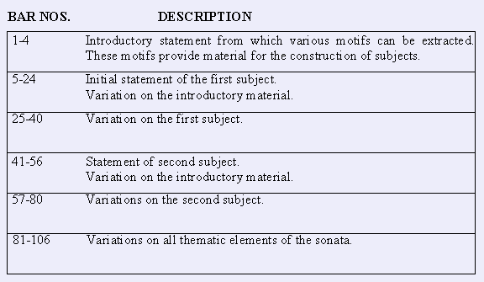

Drawing from his observations, Leiken notes that one way of understanding the exposition of the Allegro is viewing it as a sequence of variations. One might note that a similar phenomenon can be found in Schubert’s Quartet D. 887.

Leiken follows on from Samson’s reasoning for the lack of the first subject in the recapitulation. He similarly dismisses the notion that heavy exploitation of the first subject in the development renders its restatement in the recapitulation redundant, his reasoning being that all themes are quoted in the development and that it is not based almost exclusively on the first subject as stated by Leichtentritt. He adds that, since all the themes are variations of the same material, the development becomes yet another variation. Furthermore, even if the first subject were the sole basis for the development, many Classical developments based only on the first subject are followed by a full recapitulation (e.g., Beethoven’s sonata Opus 13). Leiken feels that although this approach was not used by Chopin in opus 35, it is valid in that after the material of the primary group has been atomised and thrown into various keys, it is a relief to hear it again it its original form and key. He is thus hinting that even if Chopin restated the first subject at the beginning of the recapitulation, it would not amount to a structural weakness, as maintained by Walker.

Leiken makes an interesting literary analogy here. He associates the first subject with the hero and the second with the heroine. In the typical classic sonata, they are driven apart in the exposition, to be reunited in the reprise. In the case of opus 35, however, the tonal conflict of the exposition is left unresolved; this is owing to the lack of the appearance of the first subject in the tonic key at the beginning of the recapitulation. Here, then, the hero and heroine cannot be re-united because the hero dies. The Funeral March thus follows.

Leiken offers another reason for the phenomenon of the compression of the recapitulation. He sees it as the restoration of the older binary form typical of D. Scarlatti’s sonatas in the Baroque era i.e., return to a two-part rather than three-part form. Further evidence of Baroque tendencies in Chopin’s work is seen in the contrapuntal writing of the first movement of the sonata Opus 58. Jim Samson devotes an entire chapter in The Music of Chopin to Chopin’s employment of Baroque compositional procedures.

Echoing Samson (see page 69), Leiken interprets the furious insistence on repeated octaves and chords in the Scherzo as an indication of its close connection to the Beethovenian tradition, on account of its explosive rhythmic power. He adds that while Beethoven’s scherzo is a transformed minuet, Chopin’s is a transformed mazurka, with all the characteristic jumps or stamps on the second or third beat. Leiken also attests to the notion that the Scherzo is an integral part of opus 35, citing Walker’s observation of the importance of the minor third in this movement as a unifying force throughout the four movements (see page 60). He believes that the Scherzo begins as a natural extension of the closing section of the first movement, in that the triplet-metre crotchet motion in the former (Example 34(b)) is similar to the triplets in the latter (Example 34(a)). The arrows indicate intervallic similarities. In addition, Leiken notes that the predominance of repeated octaves and chords in both movements reinforces this similarity. According to Leiken, the Scherzo’s growth out of the closing section of the first movement is one possible reason for explaining the absence of a tempo indication for the Scherzo.

Example 34: Link between the Scherzo and the first movement

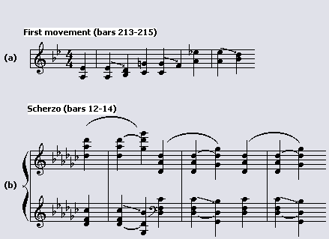

Leiken also identifies a further thematic link between the first movement and the Scherzo: the melodic line rising from the first to the fifth scale degree. This is shown in Example 35, where the circled notes make up the interval of the fifth:

Example 35: Thematic link between the Scherzo and first movement: the rising
fifth

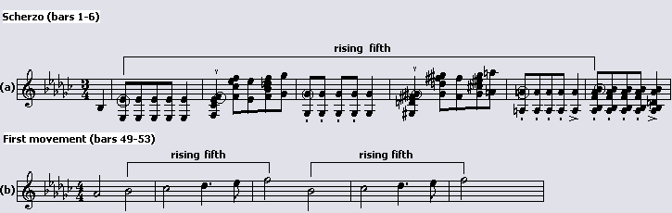

One final note concerning thematic and rhythmic interconnections between movements should be included here. Leiken points out that the prolonged repetitions of a single note seen at the beginning of the Funeral March is also the backbone of the main theme of the Scherzo and the closing section of the first movement. This is possibly the final nail in the coffin for the “lack of structural unity” theory.

This concludes the study of the reception of Chopin’s Second Piano Sonata. From the early writings of Schumann to the very recent ones of Samson, a definite trend of increased awareness and understanding of this work is noticeable. Before concluding this dissertation, however, a separate chapter will be devoted to the Finale. While it has been touched upon earlier, many remarks have been deliberately held back until this point. An attempt will be made to trace the problematic reception of this movement by examining the writings of various commentators, almost all of whom have already been mentioned in the dissertation.

CHAPTER 10

THE FINALE

As noted in Chapter Three, it was the Finale of Chopin’s second piano sonata that puzzled Schumann most. He viewed it more as a piece of irony than music. It has captured the imagination of many, causing hosts of commentators to extend their views as to the literary associations of this movement. On the face of it, seventy-five bars of quick, non-stop triplet passages in unison between the two hands with hardly a change in dynamics may seem like a strange choice for the final movement of a sonata. Modern commentators have tried to demystify this movement by means of harmonic and motivic analyses. These analyses will be discussed in due course; first, however, a glance at some reactions to this movement provides interesting reading.

Frederick Niecks describes this finale as “the solitude and dreariness of a desert.” The famous nineteenth-century Russian pianist Anton Rubinstein interprets it as “Winds of night sweeping over churchyard graves.” Tausig described the “very peculiar” finale as “…the ghost of the departed wandering about” after the “Marche funèbre”; subsequently, only two weeks before his own death in 1871, he referred to it as “…the wind blowing over my grave.” Alfred Cortot saw “…the freezing whirlwind descending on tombs.” Mendelssohn was known to dislike the work, saying, “One may abhor it, yet it cannot be ignored.” With reference to Chopin’s comment that the hands are “gossiping” after the march, Niecks interprets this as the good neighbours discussing the merits of the departed after the burial, albeit with a spice of backbiting.

According to Jurij Cholopow, a survey of writings on the Finale shows that it has been accused of a lack of melody, obscure and undefined harmony, lack of subjects, as well as a lack of formal clarity. These views are by no means confined to the early- twentieth century either. In an article of 1985, Peter Benary concludes that the musical sense of the Finale remains “hidden.”

Jim Samson highlights the extraordinary construction of the single line in this movement, both in terms of phrasing and implied harmonic background. He describes the effect of the Finale as “…rather like a film sequence coming in and out of focus, with moments of relative diatonic clarity…undermined by the shifting, seemingly directionless activity surrounding them.” Diatonic clarity can be seen in the opening, bars 24-30 (established through literal repetition), the reprise at bar 34, and the final bars. For the rest of the movement, repeated shapes emerge only tentatively from a continuous stream of sound, thereby increasing the elusive quality.

Anatoly Leiken views the finale like a piece for unaccompanied cello, an instrument with which Chopin was well acquainted. Leiken notes that the Prelude from Bach’s Suite in D major for solo cello BWV1012 is a similar perpetuum mobile of four quaver triplets per bar, and that one of its main motives bears a striking resemblance to the main theme of the first movement of Chopin’s opus 35. This parallel adds to his argument that the Finale should not be played too fast, or else not much remains of a Bach connection in such a performance, and the listener will have no chance of grasping the Finale’s form. In addition, a fast rendition will cause the movement to appear athematic, whereas in reality it has “…a system of tonal and melodic repeats that creates a tangible trace of sonata form.”

Charles Rosen views the Finale as “…so much less radical than this Polonaise [in F Sharp Minor Opus 44] that it may be difficult at first to put one’s finger on just why Schumann and his contemporaries were shocked by it to the point of considering it unmusical, although it is easy to understand why they were fascinated.” Formally, he sees it as a one-part invention in relatively simple binary form. He adds that this kind of binary “sonata” form without development was common from 1750 to 1800, after which it appeared frequently in opera overtures such as those of Rossini and Berlioz.

Understanding the construction of the Finale is possible by means of a thematic and harmonic analysis, such as those by Riemann, Leichtentritt, Bronarksi, and Benary. This dissertation will reproduce that found in a 1987 Polish article by Jurij Cholopow, the translated title of which is “About principles of Chopin’s compositions: Mystery of the finale of the B Flat Minor Sonata.” Part of this analysis can be found in Appendix B, a basic summary of which follows.

The first four bars have been viewed by some as an introduction, while others interpret it as the beginning of the first subject. Charles Rosen subscribes to the former view, adding that its harmonic outline recalls the opening four bars of the first movement. Cholopow’s analysis takes the latter view, interpreting the first four bars as the first subject, and bar 5 as the beginning of an episode.

Bars 5 to 23 form a largely chromatic episode (a term used by Cholopow but not Rosen), although the harmony gradually settles on the dominant of the relative major (D-flat). A new, secondary theme enters in D flat major in bar 23 and is repeated an octave higher beginning at bar 27. In bar 31, another episode (not so called by Rosen) begins in which the dominant of B-flat minor is carefully prepared, in Rosen’s words, “in the most respectable Classical fashion,” by its own dominant.

Bar 39 marks the beginning of the recapitulation with a literal repeat of bars 1 to 8, with another episode appearing in bar 47. This reprise also contains elements of the first episode and the secondary theme which are developed toward a cadence. For example, bars 63-64 clearly recall bars 23-27, while bars 17-18 are recalled in bars 57-58 and 61-62. Views as to the location of the beginning of the coda seem to differ. Rosen believes it begins in bar 65 on the implied dominant pedal, while the analysis used here points to bar 69 as the beginning.

Rosen calls the final cadence an anticipated tonic in that the fundamental base note is reached tentatively four times over a weak beat in bars 72-74. Harmonically, the piece ends in bar 73, which gives the fortissimo of the last bar all the more impact.

Cholopow highlights the fact that this movement reveals characteristics of the small “bi-thematic” rondo, which are:
- The fact that the rondo is a common form for a final movement.
- The characteristics of perpetuum mobile of the final movement of opus 35 are similar enough to the “rolling” character of a typical rondo that is attained through continuous, even rhythmic motion.
- Alternation of subjects and episodes as shown in the analysis (typical of all rondos).
- Rondos have two, not three, subjects. This last point is debatable.

It is interesting to note that all these characteristics, typical of a rondo, are present in the finale of Chopin’s next sonata (opus 58), that is undoubtedly in rondo form. In addition, Cholopow notes that the structural outline of the Finale of opus 58 is the same as Chopin’s other works in rondo form i.e., Rondo opus 5, Rondo opus 73, Rondo opus 16, and the third movement of the sonata opus 65. Furthermore, both Finales of opus 35 and opus 58 are characterised by a similar general structure as shown in Table 2:

Table 2: Structural outline of the Finales of Chopin’s sonatas opus 35 and
opus 58

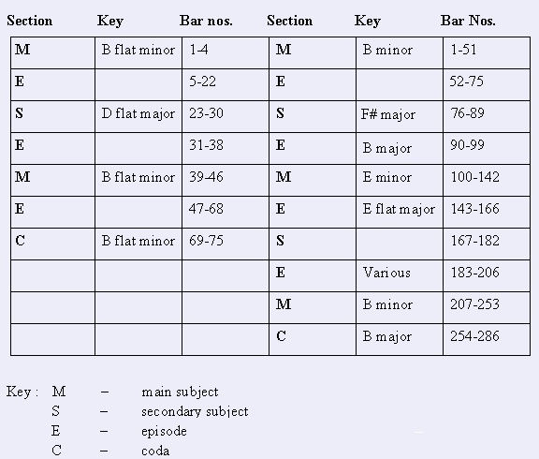

There are, however, two important differences. Firstly, in opus 35 there is no repetition of the secondary subject or the second recapitulation of the main subject. Cholopow maintains that although this contracts the scheme of bi-thematic rondo form, it does not contradict its “rondo-like” quality. Secondly, the extraordinary terseness of the main subject of opus 35 differs markedly from the expansiveness of that in opus 58. Cholopow attributes these differences to the small dimensions of the Finale of opus 35.

Cholopow’s harmonic analysis of this Finale (as shown in Appendix B) has thus uncovered some interesting details. The outline of key subject material and underlying harmonies allows for the identification of an overall structure of an apparently obscure movement. These findings are contrary to the criticisms noted earlier - obscure, undefined harmony, lack of subjects and lack of formal clarity. Cholopow’s observation that this Finale is similar in structural outline to Chopin’s other movements in rondo form provides further substantiation for the belief that this movement does exhibit a clear formal structure. It is also possible that Chopin was comfortable with the Finale of opus 35, or else he probably would not have used a similar structural outline five years later in opus 58, given the negative critical appraisal relating to opus 35.

CHAPTER 11

CONCLUSION

This brings to an end a survey of the long and interesting history relating to the reception of Chopin’s piano sonata in B flat Minor opus 35. The content and order of this dissertation was organised so as to highlight the change in receptive trend as it occurred around the mid-nineteenth to the late-twentieth centuries. This trend has been shown to exhibit a turning point around 1920 with the writings of Hugo Leichtentritt.

The change in receptive trend is in part due to a better understanding of the sonata cycle and sonata form. The evolution thereof began in the early Baroque era with the multi-movement suite. This continued with the appearance of the Classical sonatas of Haydn, Mozart, and Beethoven; the sonatas of Beethoven showing remarkable poetic licences and digressions from those of Haydn and Mozart. Already by this stage, a significant compression of the form was evident, especially in the later piano sonatas of Beethoven (although an expansion of the form is also seen in Beethoven’s late Hammerklavier piano sonata). The Romantic composers continued the line of evolution, one of the most important results of which was the mixing of various forms and characters under the title “sonata.” Chopin’s experimentation with these forms and characters is no more apparent than in his second piano sonata. Here he mixes variation and sonata principles in the first movement, uses a three-layered form for the Scherzo, uses a slow Funeral March as the third movement instead of the second (the second being traditionally the home of the slow movement), and ends the work with a bi-thematic rondo lasting around seventy-five seconds.

Just as Haydn and Beethoven substituted a scherzo in place of the minuet, and introduced the fugue into their sonatas (Beethoven opus 106) and quartets (Haydn opus 20), similarly, Chopin placed his own forms into his sonatas. As observed by Jozef Chominski, Chopin used the four-movement scheme as a context within which he could include the cantilene of the nocturnes, the figurative patterns of the studies and preludes, and the periodicity of the dance pieces. Here again, this can be interpreted as a contribution toward to the development and evolution of sonata form and the sonata cycle itself.

Around the time of its composition, it is no wonder that this sonata raised a few eyebrows. Even though Schumann expresses his reservations about this work, one can definitely see that he did admire some aspects of it. It is interesting that he attests to the idea that musical tastes change over time, by stating that “…a grandson will be born and raised, will dust off and play the sonata, and will think to himself, ‘The man [Chopin] was not so wrong after all.’” It is almost as though he expected future musicologists to dispute his views through studies and analyses of the work. These studies have done just that, and have been outlined in Chapters Seven to Ten.

It is interesting to note not only the change in reception toward Chopin’s opus 35, but also the manner in which commentators substantiated their opinions. The writings of the nineteenth century clearly show a narrative approach while those of the latter part of the twentieth century are more analytical in style. It cannot be said that one is of more value than the other, although it may appear that the analytical writings show a better substantiation of the opinion of the writer. As mentioned before, it must be remembered that analyses are subjective in nature.

In conclusion, it might be added that the survey of critical appraisal of Chopin’s opus 35 has highlighted one important facet of the history of the sonata cycle: that the sonata evolved over time. Chopin’s opus 35 can be viewed as one of those works that ensured the continuation of the sonata’s journey; a journey of evolution and adaptation to new compositional techniques and styles.

APPENDIX A

SCHUMANN’S CRITIQUE (1841) OF CHOPIN’S OPUS 35

To look at the first measures of the . . . sonata and still not be sure who it is by, would be unworthy of a connoisseur. Only Chopin starts so and only he ends so, with dissonances through dissonances in dissonances. And yet, how much beauty this piece contains. What he called “Sonata” might better be called a caprice, or even a wantonness [in] that he brought together four of his wildest offspring perhaps in order to smuggle them under this name into a place where they otherwise might not fit. One imagines some cantor, for example, coming from the country into a music centre in order to buy some good music; he is shown the newest [things]; he will have none [of them]; finally a sly fox shows him a “sonata”; “yes”, he says happily, “that is for me and a piece still from the good old days”; and he buys and gets it. Arriving home he goes at the piece-but I would have to be very wrong if, before he even gets painstakingly through the first page, he will not swear by all the holy musical ghosts that this [is] no ordinary sonata style but actually godless [trash]. Yet, Chopin has still accomplished what he wanted; he finds himself in the cantor’s home, and who knows whether in that very home, perhaps years later, a romantic [-ally inclined] grandson will be born and raised, will dust off and play the sonata, and will think to himself, “The man was not so wrong after all.”
With all this, a half judgement has already been offered. Chopin no longer writes anything that could be found as well in [the works of] others; he remains true to himself and has reason to.
It is regrettable that most pianists, even the cultivated ones, cannot see and judge beyond anything they can master with their own fingers. Instead of first glancing over such a difficult piece, they twist and bore (their way) through it, measure by measure; and then when scarcely more than the roughest formal relationships become evident, they put it aside and call it “bizzare, confused etc.”. Chopin in particular (somewhat like Jean Paul) has his decorative asides and parentheses, over which one should not stop too long at the first reading in order not to lose the continuity. Such places one finds on almost every page in the sonata, and Chopin’s often arbitrary and wild chord writing make the detection [of the musical goals] still more difficult. To be sure, he does not like to enharmonize, if I may call it that, and so often gets measures and keys in ten or more sharps, which [extremes] we can tolerate only in the most exceptional cases. Often he is justified, but often he confuses without reason and, as stated, alienates a good part of the public in this way, who, that is, do not care to be fooled all the time and to be driven into a corner. Thus, the sonata has a signature of five flats, or B-Flat minor, a key that certainly cannot boast any special popularity. The beginning goes thus: [The opening four measures are quoted.]
After this typically Chopinesque beginning follows one of those stormy passionate phrases such as we already know by Chopin. One has to hear it played frequently and well. But this first part of the work also brings beautiful melody; indeed, it seems as if the Polish national favour that inhered in most of the earlier Chopin melodies vanishes more and more with time, [and] as if even he sometimes turned (beyond Germany) towards Italy. One knows that Bellini and Chopin were friends, that they often told each other of their compositions, [and] probably were not without artistic influence on each other. However, as suggested, it is only a slight leaning toward the southern manner. As soon as the melody ends, the whole [barbarian tribe of] Sarmatae flashes forth again in its relentless originality and tumult. At least, Bellini never dared to write and never could write a crisscross chord pattern such as we find at the end of the first theme in the second part [undoubtedly mss. 138-53]. And similarly, the entire movement ends [but] little in Italian fashion, which reminds me of Liszt’s pertinent remark. He once said, Rossini and his compatriots always ended with a “vôtre tres humble serviteur,” but not so Chopin, whose finales express rather the opposite.
The second movement is only the continuation of this mood, daring, sophisticated, fantastic, [with] the trio delicate, dreamy, entirely in Chopin’s manner: [that is,] a Scherzo only in name, as with many of Beethoven’s [scherzos]. Still more somber, a Marcia funebre follows, which even has something repulsive [about it]; an adagio in its place, perhaps in D Flat, would have had a far more beautiful effect. What we get in the final movement under the title “Finale” seems more like a mockery than any [sort of] music. And yet, one has to admit, even from this unmelodic and joyless movement a peculiar, frightful spirit touches us, which holds down with an iron fist those who would like to revolt against it, so that we listen as if spellbound and without complaint to the very end, yet also without praise, for music it is not. Thus the sonata ends as it began, puzzling, like a sphinx with mocking smile.

APPENDIX B:

ANALYSIS OF THE FINALE OF CHOPIN’S PIANO SONATA IN B FLAT MINOR, OPUS 35

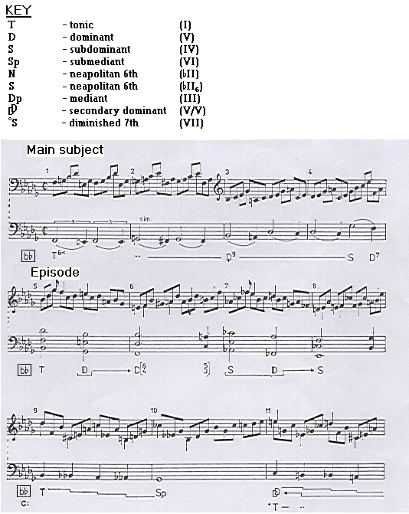
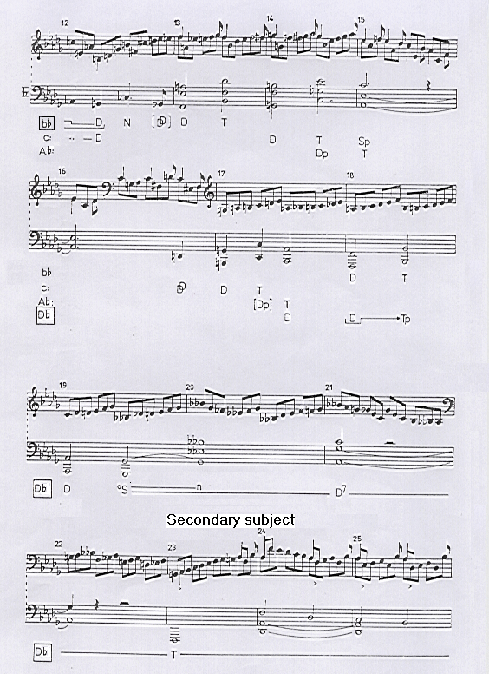

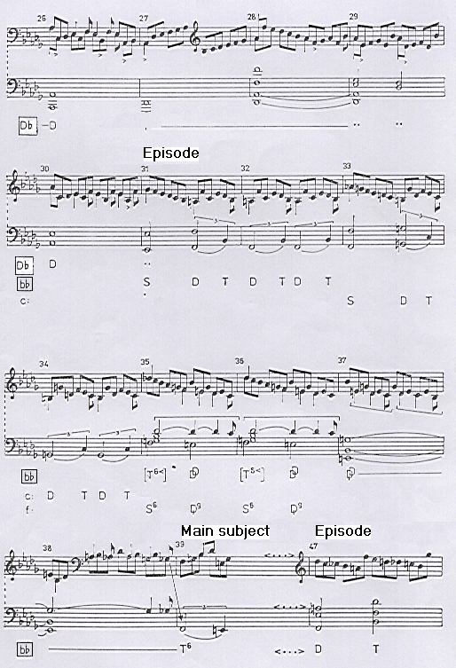

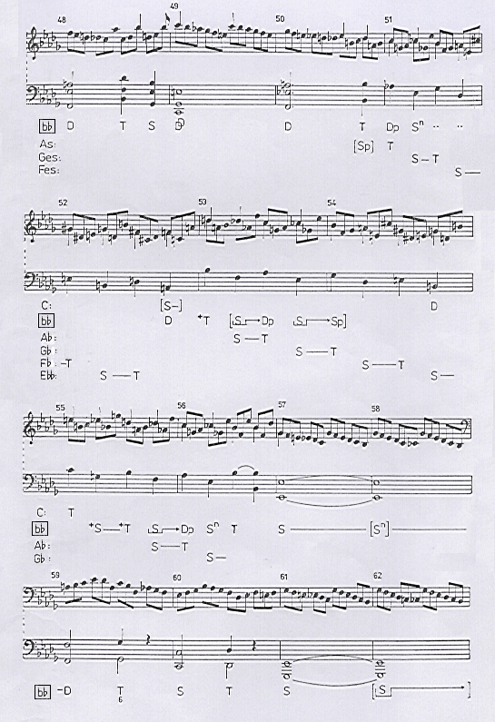

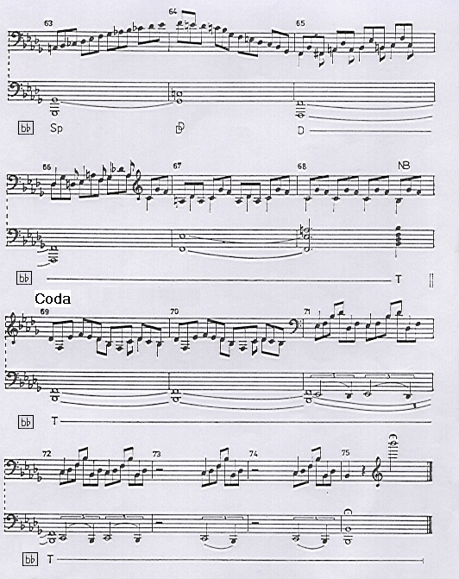

BIBLIOGRAPHY

Abraham, Gerald. Chopin’s Musical Style (London: Oxford University Press, 1939).

Ates, Orga. Chopin: His Life and Times (Kent: Midas books, 1976).

Atwood, William G. Fryderyk Chopin: Pianist from Warsaw (New York: Columbia University Press, 1987).

Benary, Peter. ‘Ein Fall von Fehlinterpretation,’ Musica 39 (1985), pp. 26-28.

Bollinger, John S.I. An Integrative and Schenkerian Analysis of the B-Flat Minor Sonata of Frederic Chopin. Ph.D dissertation, University of Washington, 1981.

Bidou, Henry. Chopin, tr. Phillips, C.A. (New York: Tudor Publishing Co., 1936).

Chechlinska, Zofia. ‘Chopin Reception in Nineteenth-century Poland,’ in The Cambridge Companion to Chopin ed. Samson, J. (Cambridge: Cambridge University Press, 1992).

Cholopow, Jurij. ‘O Zasadach Kompozycji Chopina: Zagadka Finalu Sonaty B-moll,’ in Rocznik Chopinowski XIX (1987).

Chopin, Frédéric. Klaviersonate b-moll opus 35 (München: G. Henle Verlag, 1976).

Chopin, F. Ballades ed. Cortot, A. (Paris: Salabert, 1957).

Dammier-Kirpal, Ursula. Der Sonatensatz bei Frederic Chopin (Wiesbaden: Breitkopf & Härtel, 1973).

Davison, J.W. Essays on the Work of Frederic Chopin (London: Wessel & Co., 1843).

Finck, Henry T. Chopin and Other Musical Essays (London: T. Fisher Unwin, 1889).

Gavoty, Bernard. Frederic Chopin, tr. Sokolinskes, M. (New York: Charles Scribner’s sons, 1977).

Gould, Peter. ‘Concertos and Sonatas,’ in Frédéric Chopin: Profiles of the Man and the Musician ed. Walker, A. (London: Barrie & Rockcliff, 1966).

Hadden, J. Cuthbert. The Master Musicians: Chopin (London: J.M. Dent and Sons Ltd, 1903).

Hedley, Arthur. The Master Musicians: Chopin, revd. Maurice J.E. Brown (London: J.M. Dent & Sons Ltd, 1974).

Helman, Zofia. ‘Norma indywiduacja w sonatach Chopina,’ in Musica Iagellonica (1993), pp. 43-68.

Huneker, James. Chopin: The Man and His Music (New York: Charles Scribner’s Sons, 1900).

Jonson, G.C. Ashton. A Handbook to Chopin’s works (London: William Reeves, 1905).

Kaiser, Joachim. ‘Chopin und die Sonate,’ in Musik-Konzepte 45 (1985), pp. 3-16.

Kelley, Edgar S. Chopin the Composer: His Structural Art and its Influence on Contemporaneous Music (New York: G. Schirmer, 1913).

Klein, Rudlof. ‘Chopins Sonatentechnik,’ in Oesterreichische Musikzeitschrift XXII/7 (1967), pp. 389-399.

Leichtentritt, Hugo. Analyse der Chopin’schen Klavierwerke, Vol. II (Berlin: Max Hesse, 1921-1922).

Leiken, Anatoly. The Dissolution of Sonata Structure in Romantic Piano Music (1820-1850). Ph.D dissertation, University of California, Los Angeles, 1986.

Leiken, Anatoly. ‘The Sonatas,’ The Cambridge Companion to Chopin ed. Samson, J. (Cambridge: Cambridge University Press, 1992).

Liszt, F. The Life of Chopin, tr. Cook, M.W. (New York: Leypoldt & Holt, 1866).

Mareck, George R. and Gordon-Smith, M. Chopin (London: Weidenfeld & Nicolson, 1978).

Newman, William S. The Sonata in the Classic Era (New York: W.W. Norton & Co., 1963).

Newman, William S. The Sonata since Beethoven (New York: W.W. Norton & Co., 1972).

Niecks, Frederic. Frederic Chopin as a Man and Musician, Vol II (London: Novello, Ewer and Co. Ltd, 1890).

Opienski, Henryk. Chopin’s Letters, tr. Voynich, E.L. (New York: Alfred A. Knopf, 1931).

Protopopov, Vladimir. ‘Forma Cyklu Sonatowego w utworach F. Chopina,’ in Polsko-rogyjskie miscellanea muzyczne (1968), pp. 126-140.

Réti, Rudolph. The Thematic Process in Music (Connecticut: Greenwood Press, 1951).

Rosen, Charles. ‘The First Movement of Chopin’s Sonata in B Flat Minor, Op. 35,’ in
Nineteenth-century Music XIV/1 (1990), pp. 60-66.

Rosen, Charles. The Romantic Generation (London: Harper Collins, 1995).

Rosen, Charles. Sonata Forms (New York: W.W. Norton and Co., 1988).

Samson, Jim. ‘Chopin Reception: Theory, History, Analysis,’ Chopin Studies II ed. Samson, J., and Rink, J. (Cambridge: Cambridge University Press, 1994).

Samson, Jim. The Music of Chopin (London: Routledge & Kegan Paul, 1985).

Samson, Jim. Chopin (Oxford: Oxford University Press, 1996).

Schumann, Robert. Gesammelte Schriften über Musik und Musiker von Robert Schumann I & II (Leipzig: Breitkopf & Härtel, 1914).

Siepmann, Jeremy. Chopin: The Reluctant Romantic (London: Victor Gollanoz, 1995).

Walker, Alan. ‘Chopin and Musical Structure: an Analytical Approach,’ Frédéric Chopin: Profiles of The Man and The Musician ed. Walker, A. (London: Barrie and Rockcliff, 1966).

Weinstock, Herbert. Chopin: The Man and His Music (New York: Alfred A. Knopf, 1959).

Willeby, Charles. Frederic Francois Chopin (London: Sampson Low & Co., 1892).

Schumann’s critique of this sonata, dating from 1841, can be found in Appendix A.
Chechlinska, Zofia. ‘Chopin Reception in Nineteenth-Century Poland,’ The Cambridge Companion to Chopin, ed. Samson, J. (Cambridge: Cambridge University Press, 1992), p. 214.
Chopin returned many times to Nohant for the summer in the early 1840s; many of his masterpieces were composed there e.g., the third Ballade, the Fantasy opus 49, and the F sharp Minor Polonaise opus 44.
Gavoty, Bernard. Frederic Chopin, tr. Sokolinsky, M. (New York: Charles Scribner’s Sons, 1977), p. 234.
ibid., p. 386.
Opienski, Henryk. Chopin’s Letters, tr. Voynich, E.L. (New York: Alfred A. Knopf, 1931), p. 204.
Siepmann, Jeremy. Chopin: The Reluctant Romantic (London: Victor Gollancz, 1995), p. 153.
Samson, Jim. The Music of Chopin (London: Routledge and Kegan Paul, 1985),p. 129.
ibid., p. 129.
The opinions as to the form of this final movement vary: See Chapter 10 for an analysis.
Leiken, Anatoly. ‘The Sonatas,’ The Cambridge Companion to Chopin, ed. Samson, J. (Cambridge: Cambridge University Press, 1992), p.161.
ibid., p. 161.
Protopopov, Vladimir. ‘Forma Cyklu Sonatowego w utworach F. Chopina,’ in Polsko-rogyjskie miscellanea muzyczne (1968), p. 128.
Newman, William S. The Sonata Since Beethoven (New York: W.W. Norton and Co., 1972), p. 491.
ibid., p. 493.
Chechlinska, Zofia. ‘Chopin Reception in Nineteenth-Century Poland,’ The Cambridge Companion to Chopin, ed. Samson, J. (Cambridge: Cambridge University Press, 1992), p. 213.
Atwood, William G. Frederyk Chopin: Pianist from Warsaw (New York: Columbia University Press, 1987), p. 195.
Chechlinska, Zofia. ‘Chopin Reception in Nineteenth-Century Poland,’ The Cambridge Companion to Chopin, ed. Samson, J. (Cambridge: Cambridge University Press, 1992), p. 214.
ibid., p. 214.
Chopin, F. Ballades ed. Cortot, A. (Paris: Salabert, 1957), p. 49.
Chechlinska, Zofia. ‘Chopin Reception in Nineteenth-Century Poland,’ The Cambridge Companion to Chopin, ed. Samson, J. (Cambridge: Cambridge University Press, 1992), p. 220.
Samson, Jim. The Music of Chopin (London: Routledge & Kegan Paul, 1985),p. 129.
Chechlinska, Zofia. ‘Chopin Reception in Nineteenth-Century Poland,’ The Cambridge Companion to Chopin, ed. Samson, J. (Cambridge: Cambridge University Press, 1992), p. 210.
Newman, William S. The Sonata Since Beethoven (New York: W.W. Norton and Co., 1972), p. 34. Interpolations are Newman’s. Unless otherwise stated, all interpolations are my own.
ibid., p. 34.
Davison, J.W. Essays on the Work of Frederic Chopin (London: Wessel and Co., 1843), p. 7.
Chechlinska, Zofia. ‘Chopin Reception in Nineteenth-Century Poland,’ The Cambridge Companion to Chopin, ed. Samson, J. (Cambridge: Cambridge University Press, 1992), p. 216.
Finck, Henry T. Chopin and Other Musical Essays (London: T. Fisher Unwin, 1889), pp. 40-41.
Jonson, G.C. Ashton. A Handbook to Chopin’s Works (London: William Reeves, 1905), p. 199.
ibid., p. 200.
Newman, William S. The Sonata Since Beethoven (New York: W.W. Norton and Co., 1972), p. 490.
Liszt, Franz. Life of Chopin, tr. Cook, M.W. (New York: Leypoldt & Holt, 1866), p. 23.
Niecks, Frederick. Frederick Chopin as a Man and Musician, Vol II (London: Novello, Ewer and Co., 1890), p. 225.
ibid., p. 225.
ibid., p. 226.
Willeby, Charles. Frederic Francois Chopin (London: Sampson Low & Co., 1892), p. 225.
ibid., pp. 228-229.
ibid., p. 231. All interpolations except the final one are those of the author.
Kelley, Edgar. Chopin The Composer: His Structural Art and its Influence on Contemporaneous Music (New York: G. Schirmer, 1913), p. 153.
ibid., p. 153.
Huneker, James. Chopin: The Man and His Music (New York: Charles Scribner’s Sons, 1900), pp. 166-167.
ibid., p. 167.
ibid., p. 167.
ibid., p. 168.
Hadden, J. Cuthbert. The Master Musicians: Chopin (London: J.M. Dent and Sons Ltd, 1903), p. 186.
Leichtentritt, Hugo. Analyse der Chopin’schen Klavierwerke, Vol. II (Berlin: Max Hesse, 1921-1922),p. 210.
ibid., p. 210.
Samson, Jim. ‘Chopin Reception: Theory, History, Analysis,’ Chopin Studies II ed. Samson, J., Rink, J. (Cambridge: Cambridge University Press, 1994), p. 7.
Weismann, Adolf Chopin (Leipzig, 1912).
Scharlitt, Bernard. Chopin (Leipzig, 1919).
Samson, Jim. ‘Chopin Reception: Theory, History, Analysis,’ Chopin Studies II ed. Samson, J., Rink, J. (Cambridge: Cambridge University Press, 1994), p. 7.
ibid., p. 7.
Bidou, Henry. Chopin, tr. Phillips, C.A. (New York: Tudor Publishing Co., 1936), p. 189.
Abraham, Gerald. Chopin’s Musical Style (London: Oxford University Press, 1939), p. 59.
Chopin, Frédéric. Klaviersonate b-moll opus 35 (München: G. Henle Verlag, 1976), p. 5.
Abraham, Gerald. Chopin’s Musical Style (London: Oxford University Press, 1939), p. 107.
ibid., p. 107.
Hedley, Arthur. The Master Musicians: Chopin, revd. Brown, M.J.E. (London: J.M. Dent & Sons Ltd, 1974), p. 157. It should also be noted that in 1921 Leichtentritt offered quasi-mathematical proof of the sonata’s ‘rightness’ in his analyses of Chopin’s piano works (see Chapter Seven).
ibid., p. 157.
ibid., p. 157.
ibid., p. 157.
ibid., p. 158.
Weinstock, Herbert. Chopin: The Man and His Music (New York: Alfred A. Knopf, 1959), p. 239.
ibid., p. 239.
ibid., p. 240.
ibid., p. 241.
Ates, Orga. Chopin: His Life and Times (Kent: Midas Books, 1976), p. 104.
Mareck, George R. and Gordon-Smith, M. Chopin (London: Weidenfeld & Nicolson, 1978), p. 148.
Walker, Alan. ‘Chopin and Musical Structure: An Analytical Approach,’ Frédéric Chopin: Profiles of The Man and The Musician ed. Walker, A. (London: Barrie and Rockcliff, 1966), p. 239.
Protopopov, Vladimir. ‘Forma Cyklu Sonatowego w utworach F. Chopina,’ in Polsko-rogyjskie miscellanea muzyczne (1968), p. 126.
Gavoty, Bernard. Frederic Chopin, tr. Sokolinskes, M. (New York: Charles Scribner’s Sons, 1977), p.385.
ibid., p. 386.
ibid., p. 386.
ibid., p. 387.
ibid., p. 387.
Samson, Jim. The Music of Chopin (London: Routledge & Kegan Paul, 1985), p. 129.
ibid., p. 128.
ibid., p. 128.
Samson, Jim. Chopin (Oxford: Oxford University Press, 1996), p. 210.
Leiken, Anatoly. ‘The Sonatas,’ The Cambridge Companion to Chopin ed. Samson, J. (Cambridge: Cambridge University Press, 1992), p. 160.
Siepmann, Jeremy. Chopin: The Reluctant Romantic (London: Victor Gollanoz, 1995), p.155. Siepmann does not give examples of such second-rate works; Schumann’s Sonata opus 11 could be one.
Rosen, Charles. Sonata Forms (New York: W.W. Norton and Co., 1988), p. 4. Rosen also notes that Marx was an important factor in the creation of the myth of the supremacy of Beethoven, which explains the use of Beethoven’s procedures in Marx’s codification of sonata form.
Siepmann, Jeremy. Chopin: The Reluctant Romantic (London: Victor Gollanoz, 1995), p.155.
Rosen, Charles. The Romantic Generation (London: Harper Collins, 1995), p.283.
ibid., p. 284.
Newman, William S. The Sonata Since Beethoven (New York: W.W. Norton and Co., 1972), p. 27.
ibid., p. 31.
Newman, William S. The Sonata in the Classic Era (New York: W.W. Norton and Co., 1963), p.21.
ibid., p.23.
Helman, Zofia. ‘Norma indywiduacja w sonatach Chopina,’ in Musica Iagellonica (1993), p. 47.
Newman, William S. The Sonata Since Beethoven (New York: W.W. Norton and Co., 1972),. p. 31.
ibid., p. 30. The important points from Czerny’s opus 600 have been taken from an English translation of the original German which appear in Newman’s work (translator not named). It is important to note, however, that the terms “exposition” and “recapitulation” as used in this paragraph are not those of the translator.
ibid., p. 30.
ibid., p .31.
ibid., p. 31.
See page 28.
Newman, William S. The Sonata Since Beethoven (New York: W.W. Norton and Co., 1972),. p. 10.
ibid., p. 34.
ibid., p. 31.
ibid., p. 37.
ibid., p. 84.
ibid., p. 37.
ibid., p. 38.
ibid., p. 39.
ibid., p. 39.
ibid., p. 41.
ibid., p. 42.
Refer to page 5 for the applicable quote taken from this letter.
Walker, Alan. ‘Chopin and Musical Structure: An Analytical Approach,’ Frédéric Chopin: Profiles of the Man and The Musician ed. Walker, A. (London: Barrie and Rockcliff, 1966), p.231.
Leichtentritt, Hugo. Analyse der Chopin’schen Klavierwerke, Vol. II (Berlin: Max Hesse, 1921-1922),p. 211.
ibid., p. 212.
ibid., p. 212.
ibid., p. 212.
ibid., p. 213.
ibid., p. 225.
ibid., p. 228.
ibid., p. 225.
ibid., p. 228.
ibid., p. 213.
ibid., p. 224.
Chopin, Frédéric. Klaviersonate b-moll opus 35 (München: G. Henle Verlag, 1976), p. 18.
Leichtentritt, Hugo. Analyse der Chopin’schen Klavierwerke, Vol. II (Berlin: Max Hesse, 1921-1922),p. 218.
ibid., p. 227-228.
Chopin, Frédéric. Klaviersonate b-moll opus 35 (München: G. Henle Verlag, 1976), pp. 21-22.
Réti, Rudolph. The Thematic Process in Music (Connecticut: Greenwood Press, 1951), p. 3. It should be noted that Schoenberg used a similar method when analysing atonal works around the beginning of the twentieth century. Réti extended this analytical method by applying it to tonal works.
ibid., p. 299.
ibid., p. 301.
? ibid., pp. 299-301.
This is questionable; as noted above, Réti’s method can often be used to relate any three notes to any three others. The emphasis here is certainly on “quasi”.
ibid., p. 302.
ibid., p. 301.
ibid., p. 302. It should be pointed out that the appearance of motif Ia in the bass line could also be due to harmonic reasons – the A natural functions as a component of VII₇ in B flat minor. Of course, Réti could argue that the harmony is motivically driven.
ibid., p. 302.
The A flat here is as Réti says – an ornamentation. Asserting its importance by linking it to the introductory motif is arguable as the note is not part of the subject per se.
ibid., p. 302.
ibid., p. 302.
ibid., p. 302.
ibid., p. 303. The similarity between the first and third subjects is presumably their identical first two notes (i.e., D flat and B flat), the use of a falling semitone, and a similar contour. It should be noted, however, that they are rhythmically completely different. This shows that Réti does not regard rhythm as being very important.
ibid., p. 303.
ibid., p. 303.
ibid., p. 304.
ibid., p. 304.
ibid., p. 305.
ibid., p. 305.
ibid., p. 305.
ibid., p. 305.
ibid., p. 306.
ibid., p. 306. Réti’s emphasis.
This is questionable. Earlier, Réti refers to motif II as the stepwise decent of four notes. Bar 5, however, contains four descending tones which are not in stepwise motion.
ibid., p. 306.
ibid., p. 306.
ibid., p. 307. Finding a melodious figure such as this in a movement with over 800 continuous quavers is statistically likely.
ibid., p. 307.
ibid., p. 308.
ibid., p. 307. Réti’s emphasis.
Walker, Alan. ‘Chopin and Musical Structure: An Analytical Approach,’ Frédéric Chopin: Profiles of the Man and The Musician ed. Walker, A. (London: Barrie and Rockcliff, 1966), p. 239.
ibid., p. 240.
ibid., p. 240.
ibid., p. 240.
ibid., p. 240.
ibid., p. 241.
ibid., p. 241.
ibid., p. 241.
ibid., p. 242.
ibid., p. 244.
ibid., p. 244.
ibid., p. 244.
ibid., p. 245.
ibid., p. 246.
ibid., p. 246.
ibid., p. 246.
ibid., p. 248.
ibid., p.242.
ibid., p. 243.
ibid., p. 243. It should be noted that sonatas were being written before Bach.
ibid., p. 243.
Klein. Rudolph. ‘Chopins Sonatentechnik,’ in Osterreichische Musikzeitschrift XXII/7 (1967), p. 393.
Bollinger, John S.I. An Integrative and Schenkerian Analysis of the B-Flat Minor Sonata of Frederic Chopin. Ph.D dissertation, University of Washington, 1981, p. 3.
ibid., p. 11.
ibid., p. 24.
ibid., p. 27.
ibid., p. 1.
ibid., p. 1.
This link, namely the employment of the same type and order of movements, was discussed earlier in Chapter 2.
Dammier-Kirpal, Ursula. Der Sonatensatz bei Frederic Chopin (Wiesbaden: Breitkopf & Härtel, 1973), p. 90.
ibid., p. 90.
Leiken, Anatoly. ‘The Sonatas,’ The Cambridge Companion to Chopin ed. Samson, J. (Cambridge: Cambridge University Press, 1992), p. 161.
Kaiser, Joachim. ‘Chopin und die Sonate,’ in Musik-Konzepte 45 (1985), p. 13. Chopin’s four Scherzi are opus 20 in B minor, opus 31 in B flat minor, opus 39 in C sharp minor, and opus 54 in E major.
ibid., p. 14.
Rosen, Charles. ‘The First Movement of Chopin’s Sonata in B Flat Minor, Op. 35,’ in Nineteenth-century Music XIV/1 (1990), p. 61.
ibid., p. 60.
ibid., p. 62.
Although his work has not been used for this thesis, the writings of John Rink on the music of Chopin are also highly regarded. Among them is a book on Chopin’s piano concertos, a dissertation dating from 1989 relating the evolution of Chopin’s structural style to improvisation, and various articles in Chopin Studies II, ed. Samson, J., Rink, J. (Cambridge: Cambridge University Press, 1994), and The Cambridge Companion to Chopin, ed. Samson, J. (Cambridge: Cambridge University Press, 1992). Contact was made with Dr. Rink; he himself stated that his writings (in particular his dissertation) are not relevant to the content of this dissertation. For this reason, his contributions to the understanding of the music of Chopin have not been included.
Samson, Jim. The Music of Chopin (London: Routledge & Kegan Paul, 1985), p. 129.
Protopopov, Vladimir. ‘Forma Cyklu Sonatowego w utworach F. Chopina,’ in Polsko-rogyjskie miscellanea muzyczne (1968), p. 127.
In Samson, Jim. The Music of Chopin (London: Routledge & Kegan Paul, 1985), p. 130.
ibid., p. 130.
Samson is here referring to the absence of the first subject in the recapitulation.
It should be noted that the sonatas of Haydn do not exhibit such inclinations.
ibid., p. 132.
ibid., p. 132.
ibid., p. 132.
ibid., p. 133.
ibid., p. 133.
ibid., p. 130.
ibid., p. 131.
Leiken, Anatoly. The Dissolution of Sonata Structure in Romantic Piano Music (1820-1850). Ph.D dissertation, University of California, Los Angeles, 1986, p. 193.
After Leiken, Anatoly. ‘The Sonatas,’ The Cambridge Companion to Chopin ed. Samson, J. (Cambridge: Cambridge University Press, 1992), p. 161.
ibid., pp. 167-169.
ibid., p. 169.
ibid., p. 169.
ibid., p. 170.
ibid., p. 170.
It should be noted that contrapuntal writing is not exclusively confined to the Baroque period.
Leiken, Anatoly. ‘The Sonatas,’ The Cambridge Companion to Chopin ed. Samson, J. (Cambridge: Cambridge University Press, 1992), p. 170.
ibid., p. 170.
ibid., p. 170.
ibid., p. 171.
ibid., pp. 168,171.
ibid., p. 174.
Niecks, Frederick. Frederick Chopin as a Man and Musician, Vol II (London: Novello, Ewer and Co., 1890), p. 227.
Weinstock, Herbert. Chopin: The Man and His Music (New York: Alfred A. Knopf, 1959), p. 241.
Newman, William S. The Sonata Since Beethoven (New York: W.W. Norton and Co., 1972), p. 491.
Gavoty, Bernard. Frederic Chopin, tr. Sokolinsky, M. (New York: Charles Scribner’s Sons, 1977), p. 387.
Huneker, James. Chopin: The Man and His Music (New York: Charles Scribner’s Sons, 1900), p. 169.
Cholopow, Jurij. ‘O Zasadach Kompozycji Chopina: Zagadka Finalu Sonaty B-moll,’ in Rocznik Chopinowski XIX (1987), p. 211.
Benary, Peter. ‘Ein Fall von Fehlinterpretation,’ in Musica 39 (1985), p 28.
Samson, Jim. The Music of Chopin (London: Routledge & Kegan Paul, 1985), p. 130.
Leiken, Anatoly. ‘The Sonatas,’ The Cambridge Companion to Chopin ed. Samson, J. (Cambridge: Cambridge University Press, 1992), p. 175.
ibid., p. 175.
Rosen, Charles. The Romantic Generation (London: Harper Collins, 1995), p. 294.
ibid., p.297.
This analysis can be found on page 228 of the article, under the heading ‘Musical form as a whole’.
Rosen, Charles. The Romantic Generation (London: Harper Collins, 1995), p. 294.
ibid., p. 295.
ibid., p. 297.
ibid., p. 297.
Cholopow, Jurij. ‘O Zasadach Kompozycji Chopina: Zagadka Finalu Sonaty B-moll,’ in Rocznik Chopinowski XIX (1987), p. 232.
This is highly debatable. The rondo from Beethoven’s Sonata opus 13 does not exhibit a ‘rolling’ character. The same may be said for many other rondos.
Cholopow, Jurij. ‘O Zasadach Kompozycji Chopina: Zagadka Finalu Sonaty B-moll,’ in Rocznik Chopinowski XIX (1987), p. 233.
ibid., p. 233.
ibid., p. 233.
ibid., p. 233.
ibid., p. 233.
Samson, Jim. The Music of Chopin (London: Routledge & Kegan Paul, 1985), p. 129.
Newman, William S. The Sonata Since Beethoven (New York: W.W. Norton and Co., 1972), p. 489. Interpolation is Newman’s.
Newman, William S. The Sonata Since Beethoven (New York: W.W. Norton and Co., 1972), pp. 489-490. Interpolations are Newman’s.
Cholopow, Jurij. ‘O Zasadach Kompozycji Chopina: Zagadka Finalu Sonaty B-moll’ in Rocznik Chopinowski XIX (1987), pp. 228-232.

